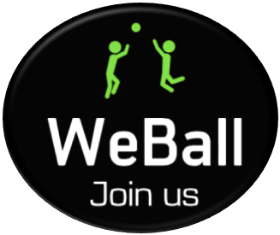

**Your Pickup Game Partner**

Mobile and IoT Computing Services: 08781/45887

**Team Members:**

Tianyu Li (tl1)

Yizhuan Jiang(yizhuangj)

Yuanyuan Zhou (yuanyuaz)

Radhika Singh(radhikas)

**Table Of Contents**

Acknowledgement……………………………………………………….2

Executive Summary……………………………………………………..3

Introduction……………………………………………………………….4

Product Overview………………………………………………………..5

Motivation………………………………………………………………..10

Revenue Model………………………………………………………....19

User Interface: Paper Prototyping…………………………………….20

User Interface: Refined………………………………………………...27

Usability Evaluation…………………………………………………….37

User Interface: Refined2………………………………………………39

Architecture……………………………………………………………...51

Privacy and Security……………………………………………………53

Conclusion and Future Development…………………………………57

Implementation Documentation……………………………………….59

Appendix…………………………………………………………………60

**Acknowledgment**

We would like to thank Professor Norman Sadeh for his invaluable guidance and insights throughout our journey. We would also like to appreciate Linda Moreci’s support on coordinating our meeting requests with Professor Sadeh.

We would also like to thank all people who have participated in our survey and user testing for their dedication and support!

**Executive Summary**

Our group developed WeBall, an android app which can help users find players and schedule time for a pickup game. When users want to organize a pickup game, they can create posts in our app by adding information such as type of ball game, location, date, time and count of players needed. Other users can view created posts and accept them. The primary function of this app is to bypass multiple channels of communication between pickup game enthusiasts and offer them a time-efficient way to organize matches.

**Introduction**

WeBall is an application that assists users in scheduling pickup matches for ball games. To set a context for the use of the application, below is a description of what pickup matches are and which sports qualify as ball games -

1. Pickup games are sports matches which are spontaneously started by a group of players. Players are invited beforehand, but they are not obligated or committed to appear for the match. Also, referees/umpires are typically not present in these matches which leaves it up to the players to decide the rules of the match for themselves.
2. Ball games, as the name indicates, includes physical sports such as basketball, football, frisbee, soccer, tennis, badminton, table-tennis, softball, volleyball, squash, ice hockey, baseball, bowling and others (and not online games).

**Product Overview**

1. **What is WeBall?**

WeBall is an Android based native application for players of pickup games. Its primary task is scheduling of pickup matches by connecting organizers and participants. However, this app has an associated social platform aspect to it also. This is because it enables any user of the app to add contacts who the user believes will be participants of pickup games in the future.

* It allows organizers to perform the below mentioned activities:
* Inviting users to use the app by importing phone contacts*
* Creating a invitation for a pickup game to be scheduled
* Add information related to date, time, location, required count of players for the pickup game in the post
* Post the invitation to all users or groups of select users
* Add comments (optional) to increase decision making effectiveness for users who can view the post**

*This feature addresses the issues described in Exhibit 1

**To be implemented in next version of the prototype

* For participants, the following functionalities are available:
* Search for pickup games posted by organizer using filters for location and time (the day the search is made)
* View information added in the post as well as comments from users who have accepted the post*
* Accept or reject invite at anytime before the post is closed**
* Create a personal profile and add information that can optionally be made public***
* View profile of other users (if profile of the user has been made public)

*Currently only users accepting the invite can add comments; but this feature will be made available to users rejecting posts in the next version of the prototype

**Post can be viewed till the end time of the game given count of accepted players remains less than or equal to total available spots

**Optional profile sharing to be included in future developments

1. **What problems do players of pickup games face?**

**Exhibit 1**: Pickup matches are unpredictable across multiple factors:

|  |  |
| --- | --- |
| **ARRIVAL TIME**  *‘Issue of coordination’*  -Coordinating start time of pickup games is time consuming - lot of time is spent in coordinating arrival time by both organizer and participants  -Coordination is not only time consuming but it involves multiple channels of coordination. | **DURATION**  *‘Players can join/drop out at any time’*  -Players who agree to participate in the pickup game not only have different arrival times, but also differ in:   1. How long they play; since there is no obligation to play, players may drop out early leaving fewer players on court/field than the minimum required 2. A participant may not want to play over the entire duration of the game |
| **FACILITIES (GROUND + EQUIPMENT)**  *‘Will the court be free at this hour?’*  -Participants hesitate from joining for a pickup game if they do not own required equipment or if are not certain that playing ground/court will be available for the duration of the pickup game | **PARTICIPATION**  *‘Will the player’s skill level match mine?’*  -Participants have their own criteria regarding who they want to play a pickup game with. Some of these include:   1. Identity of other players - some participants have security concerns if the identity of other players is unknown 2. Skill level of other players - an experienced player looking to play competitively may not want to schedule a pickup game with amateurs |

1. **What are the currently existing solutions for scheduling pickup games?**

Currently, participants of pickup games use a number of channels, often used simultaneously, to communicate with one another. These channels include:

1. Face to face scheduling
2. Mobile calls
3. Mobile texts
4. Apps: Whatsapp, WeChat, GroupMe, FB Messenger, etc.
5. Pickup game scheduling apps: OpenSports, RecCheck, Huddlers, etc.

There are multiple pickup game scheduling apps available on both Android and IoS. In terms of competition, WeBall competes directly with these apps for acquiring participants of pickup games.

1. How does WeBall fill the gap in user requirement?

Our analysis of the current landscape of pickup games scheduling methods on a high level has indicated some of the findings below listed below. These have been addressed in greater detail in the ‘user survey’ section -

1. Despite the availability of a large number of applications for scheduling pickup games, these have not yet substituted traditional channels used by players (face to face communication, mobile calls) and the more prevalent over-the-top mobile messaging services.
2. Some scheduling apps such as RecCheck are available for scheduling only a single sport, such as basketball, which limits the utility of the app.

*WeBall’s solution*: Users can select from a set of 4 popular ball games

1. Users do not find the interface of some of these apps friendly. Ex - to create a profile in OpenSports, a user is compulsorily required to upload a photograph and specify a gender. Users who did not wish to share photo and/or gender information found this step arbitrary and unnecessary to the login process and were therefore, not motivated to use the app.

*WeBall’s solution:* Users required to only submit their email ID at the time of login

1. Currently available apps have raised privacy concerns among some of the users. Ex - some apps require access to photos/media/files and device ID information. The permissions page for two such apps at the time of download are added below.

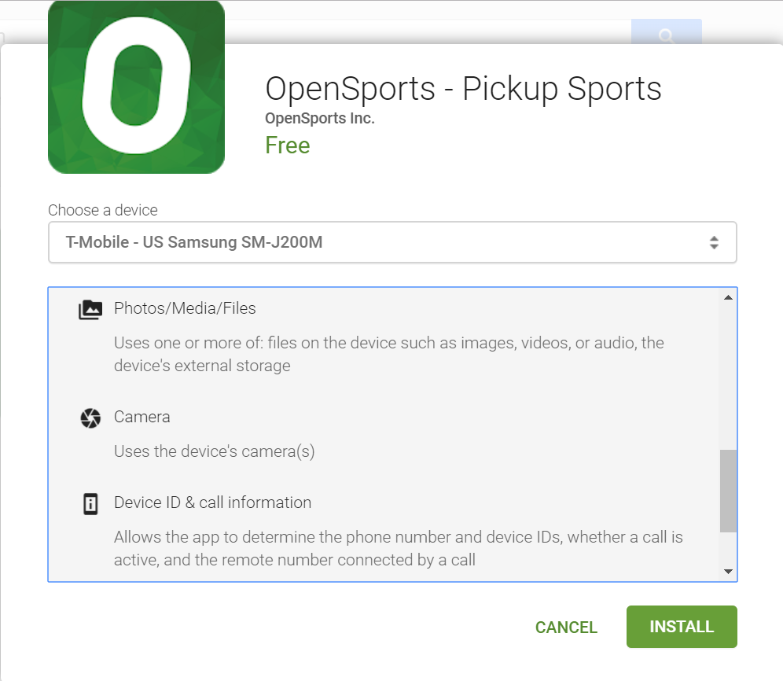

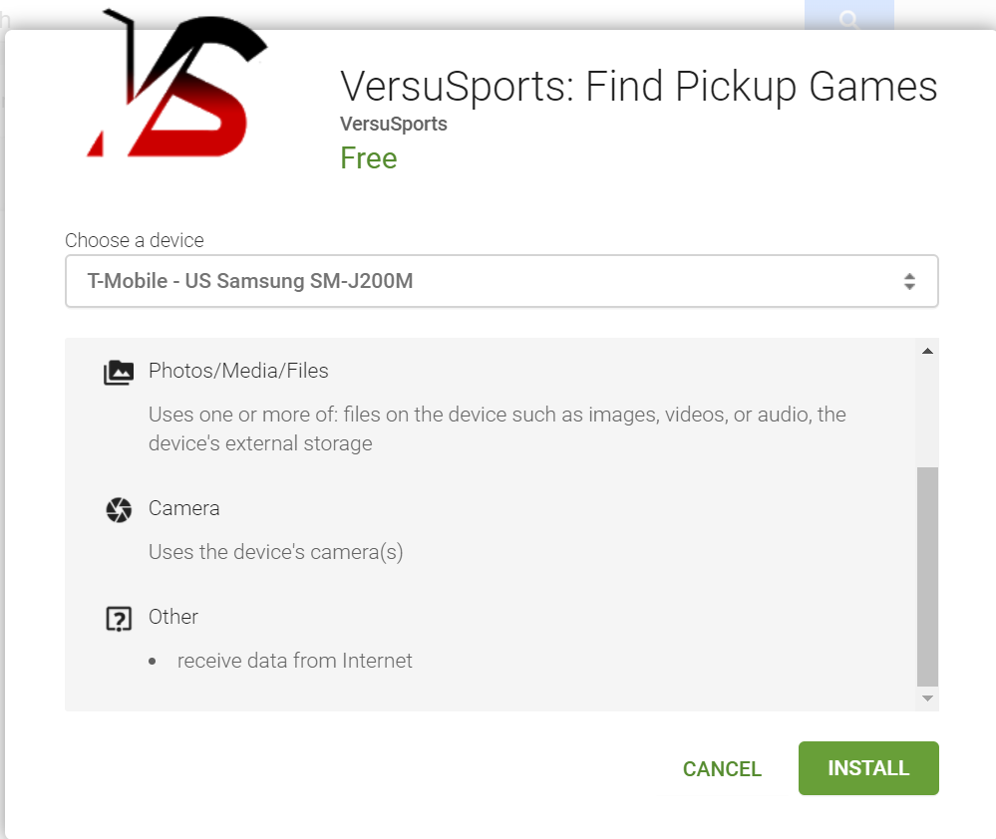

**Motivation**

This section describes the requirement gathering process for developing a UI prototype. In particular the following activities were performed to identify UI requirements and workflow -

1. Developing initial hypothesis of target users
2. Conducting pre-survey interviews
3. Survey (v1) creation and response collection
4. Interpreting survey results and identifying key features for prototype
5. Survey modification (v2) and interpretation of updated survey results
6. **Developing a hypothesis - ‘*who are the target users?***

In the context of developing an app for pickup game scheduling, we concluded that there were 2 categories of users likely to use this app -

|  |  |  |
| --- | --- | --- |
| Target groups | People who participate in pickup games and are comfortable scheduling pickup games using existing methods | Do not participate in pickup games because they have not yet identified a convenient way to schedule pickup games) |
| What WeBall can offer | Offer an improved usability experience over existing apps | Offer a convenient way to schedule pickup games using the app |

For the 1st version of this app, the target users are students across different educational levels in the following institutions -

1. Grades 9 to 12 (public schools)
2. Additional private elementary and secondary schools
3. Colleges and universities

For the first rollout, this target population made sense because students typically have access to facilities to play, equipment and most importantly a student community to find pickup game participants from.

To assess the viability of this application, a market sizing exercise was performed to understand the size of the target population within Pittsburgh (details in Appendix, item 3). 8,200+ target users are present in Pittsburgh itself. This exercise will be repeated for other college cities to obtain a national count of potential users.

1. **Conducting pre-survey interviews**

12 Tepper students including Presidents of BB club and Indoor Soccer club were interviewed to identify relevant questions for the first version of the survey. Feedback received from some of the participants on the concept of WeBall and our own viewpoint on the feedback is added in the table below -

|  |  |
| --- | --- |
| Comment/feedback | Team’s viewpoint |
| App allowing a user to connect with strangers for a pickup match - can a social media platform be associated with it? That is, allowing users to chat with one another individually? | The purpose of the app is to serve as a scheduler of pickup games.  User has the ability to add users and view profile of other users (if profile public), however, WeBall is a scheduling platform and not a social connectivity platform for pickup game enthusiasts. |
| Some games such as basketball need a degree of coordination and familiarity with team mates. Not all participants may want to play with unknown players. | Users should have the flexibility to schedule matches with players whom they are familiar with through the option of creating ‘groups’ |
| If I have arrived for a scheduled match and some participants have not turned up, I would rather still go ahead with the available players than defer the match or penalize the players who did not turn up by not inviting them for the next matches; they are not obligated to appear for a pickup match anyways. | This gave us 2 insights into the design of the prototype:   1. A player-penalty system does not make sense in pickup game schedulers 2. Invitations for a pickup game should be available for all invitees till the end of the game giving participants greater flexibility in determining their availability for a match |
| Some players have concerns that they would like to have addressed by the organizer before making a decision to accept the invitation for the pickup game. This includes information regarding:   1. Am I required to get my own equipment? 2. What is the skill level of participants? I do not want to be paired with amateurs. 3. Which court has been selected for the Tennis match? I have been meaning to play in a clay court. | The comments mentioned on the left led us to conclude that users should have enough information available to make an informed decision regarding the proposed pickup game.  For this we have provided both organizers (who create invitations) and other users (who view and accept/reject invitations), the ability to optionally add comments that contains information to address any queries that participants may have. |

1. **Survey (v1) creation, response collection and interpreting survey results to inform design**

Sample used for the survey: 43 graduate students of ECE at CMU. This sample is representative of the target population identified for WeBall (biases exist because of limited demographic variations across the sample).

|  |  |
| --- | --- |
| **Question/response** | **Guidance to prototyping** |
|  | To identify the top 4 ball games to be included in the UI - badminton, table-tennis, basketball and tennis emerged as the most popular games. |
|  | To understand the proportion of students who participate in pickup games (~20%).  The response ‘somewhat comfortable’ may include participants who participate occasionally in pickup games, however, pre-survey results indicated that this group may also include respondents who are not sure of what pickup games are in the first place and choose to answer ‘somewhat comfortable’ anyways. |
|  | To identify the breakup of competing methods for scheduling pickup games.  Over-the-top messaging applications emerge as the most important channels currently used for coordination between players (~40%). |
|  | To understand if ‘date’ filter needs to be added for players to discover games. We concluded that this filter needs to be included since playing schedules of 50% of respondents fluctuates from week to week, implying that same day invitations will not work. |
|  | #We concluded this question did not add value because:   1. Mode of travel of players varies 2. Location information will allow a player to make an informed decision about participation |
| Option-2: Proximity to game facility that I use | WeBall should offer users the ability to import contacts from phone as 35% respondents organize pickup matches with their friends and another 23% with mutual friends. |
| Option-1: I have security concerns  Option-2: I am not aware of his/her skill level  Option-3: I prefer playing with people I know | #This question did not add value because interviews indicated that if a player has arrived for a pickup match, it is likely that he/she will continue participating in it, even if other players are unknown.  However, the fact that 26% replied that they prefer playing with friends reiterates that a user is likely to opt for groups of friends to organize pickup games with. |
| Option-2: Occupation (student/full-time job/retired)  Option-4: Organizer of the match can vouch for the stranger  Option-5: Skill level (amateur/competitive/amateur) | To identify fields that WeBall should request users to share and maintain as a part of his/her profile.  Occupation emerges as the most important criteria followed with whether the organizer can vouch for an unknown player. |
|  | To determine the period up to which an invitation posted by the organizer should be available for viewing by participants.  Here, while survey results indicate that respondents prefer at least a day’s notice in advance, the results of the second survey indicate that users actually want the post to be visible till the end time of the pickup game. |

1. **Survey modification (v2) and interpretation of updated survey results**

Sample used for the survey: 17 graduate students of Tepper at CMU

|  |  |
| --- | --- |
| **Question/response** | **Guidance to prototyping** |
|  | WeBall offers participants the ability to join an ongoing pickup game after it has started, and allows them to select a time slot in which they will join the match.  This question allowed us to identify the minimum period of time that the entire duration of the pickup match should be split into (1 hour). |
|  | Question 11 in the first survey was restated to identify the longest duration over which users would like to be notified of a pickup game (rather than how much in advance they should be informed).  35% indicated that the post should remain open till the game ends - this makes sense since it offers users greater flexibility in time. |
|  | The results of the first survey and the interview indicate that organizers may behave differently from participants.  Therefore, the objective of this question was to identify the relative proportion of people who prefer organizing pickup games (~23%) versus those who prefer playing (~20% - from first survey). |
| Option-1: Contacting people is time consuming  Option-2: No sure about facilities  Option-3: Worry about people quitting after accepting invitation | Given that an equal % of people responded that they avoid organizing pickup games, this question identified some of the reasons for the same.  Coordinating people across multiple platforms is time consuming and emerges as the single most important factor which inhibits organizing pickup games. |

**Revenue Model**

Given the host of competing applications and channels currently available for users of pickup games, team WeBall rejected the option of charging users upfront at the time of download. The chosen business model is a ‘freemium’ one in which users will perform the download for free but will be charged for the below mentioned premium features -

1. Time slot function for users who have accepted an invite (provides time slot based invitation acceptance feature)

It costs a lot to store data, so we decide to charge users with more data to store.

1. Ability to have more game options.
2. Form Groups with more than 20 users.
3. Participate in more than 10 games.

**User Interface: Paper Prototyping**

Based on our discussion and the first survey result, we build our initial paper prototyping to illustrate main functions of WeBall. There are 5 major parts in the application: Sign in, Me, Create Post, Discover Games and My Games.

**Sign In**

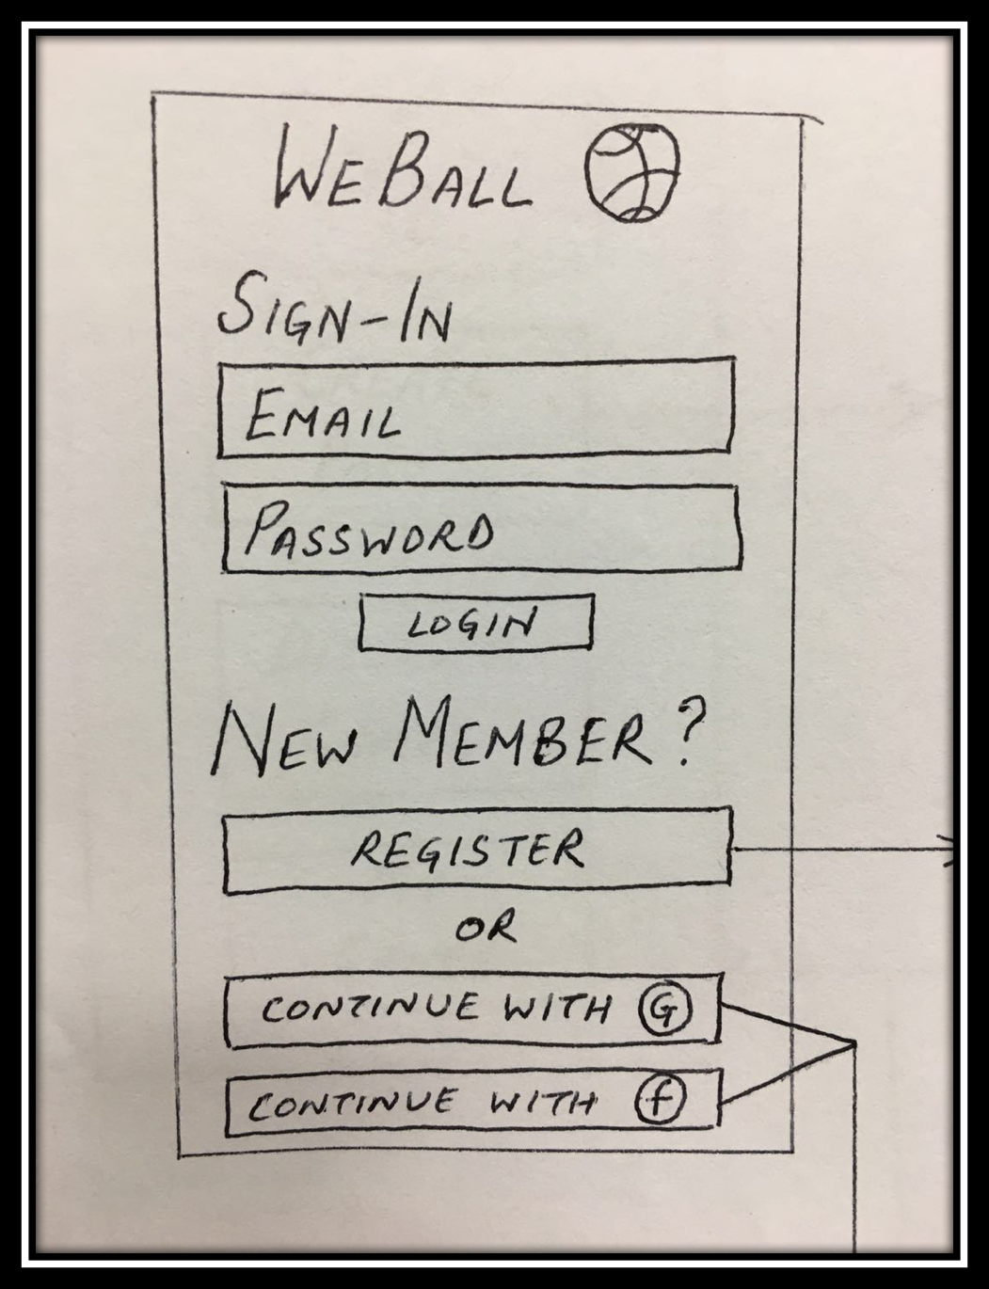

Figure 1

Figure 1 above is the first page of WeBall. Users can sign in with their WeBall account or through the third party like Google and Facebook. If someone is the new member, he/she can create a WeBall account using their email . After verifying his/her email (like Figure 2), he/she has created a WeBall account successfully.

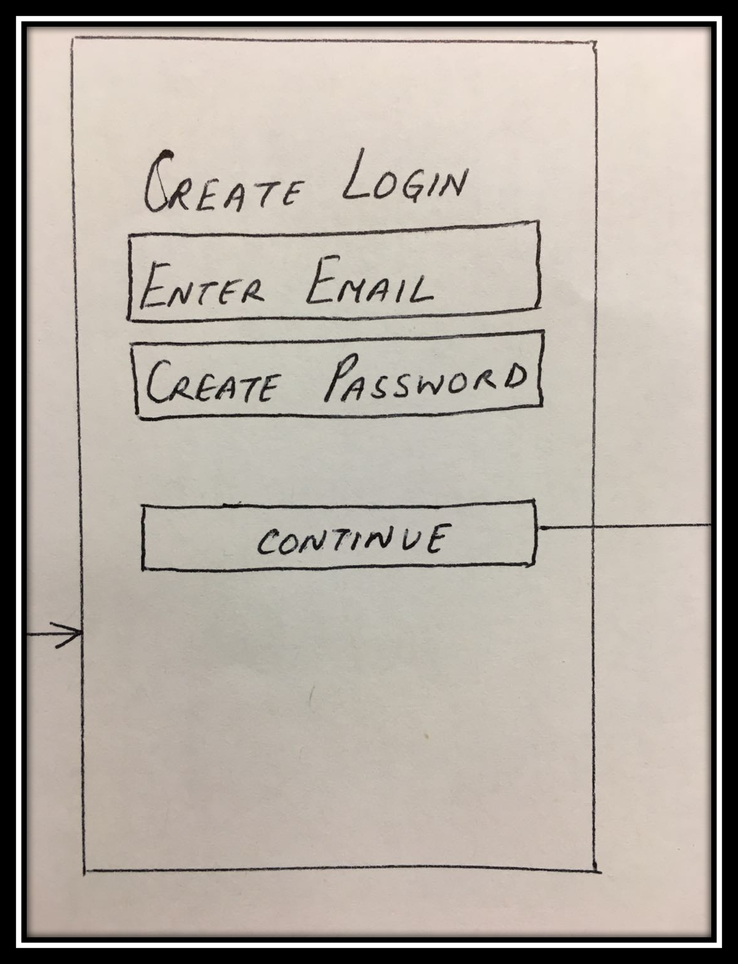

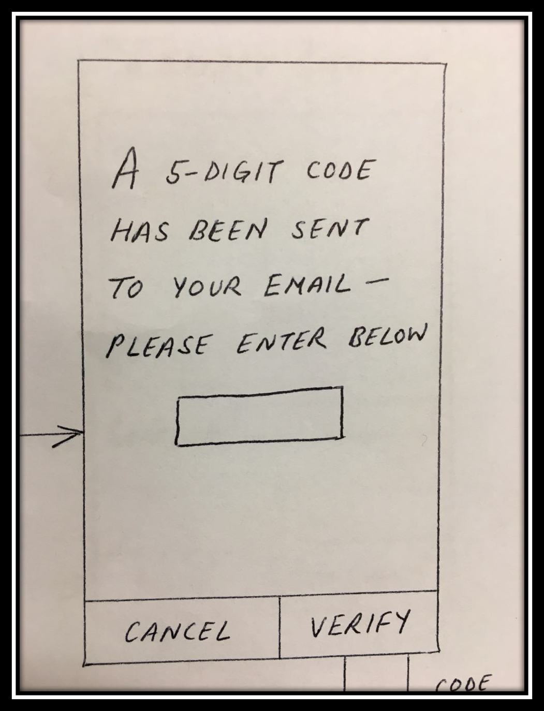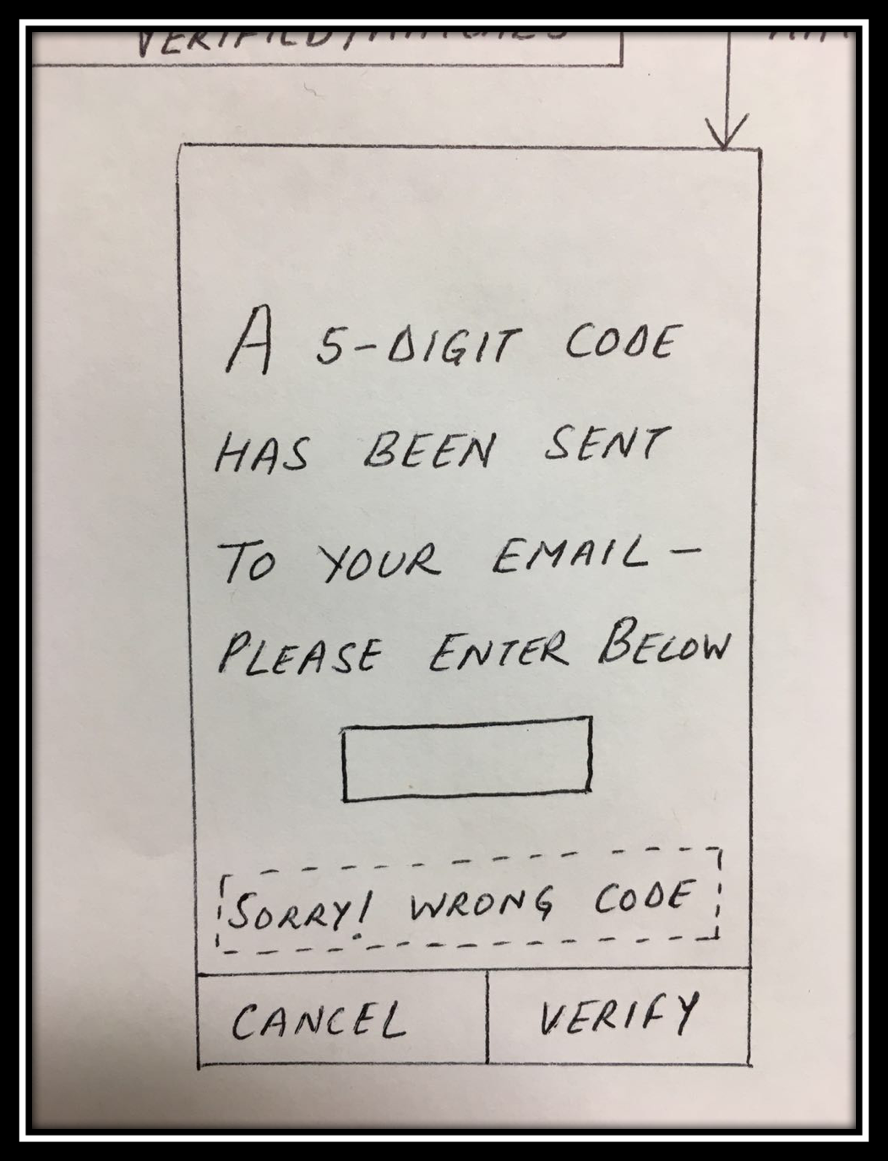

Figure 2

**Home page**

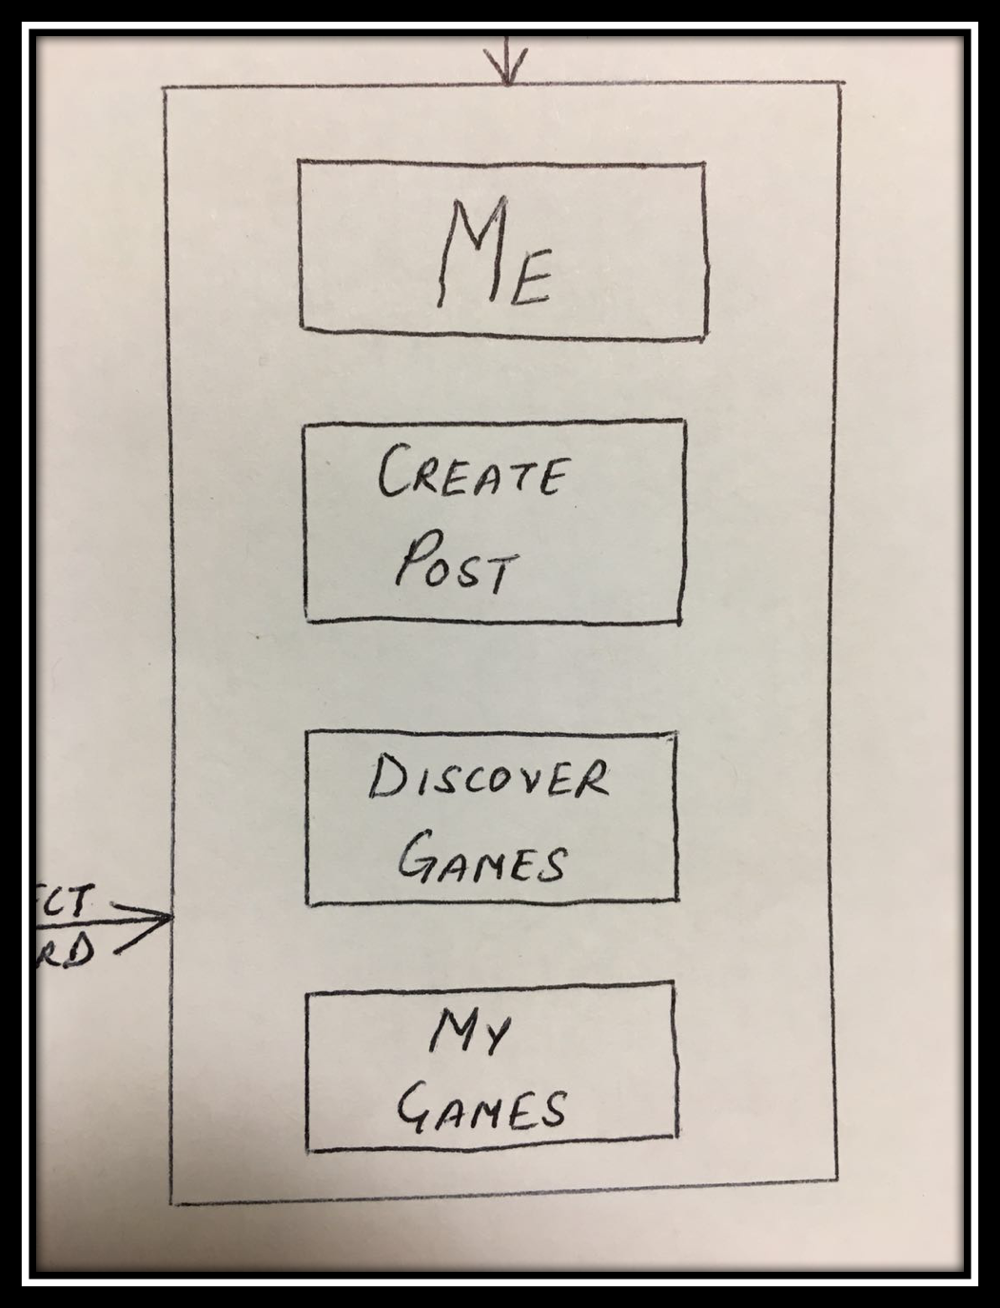Figure 3 is home page of WeBall, which has 4 buttons. These 4 buttons actually indicate the main functions of WeBall. We come up with the main functions according to our survey results and interviews. Users will have their own profile. They can create posts and discover games, and they also can view their upcoming games.

Figure 3

**ME**

ME is actually a profile for every user. As it shows in Figure 4, once users click “ME” button, they can see their profiles. In the profile, there are informations about Account ID, name, email and phone number. The Account ID is unique to every user, which is convenient for users to add friends. Name and email is necessary and they are provided by users. Phone number is optional in case that someone feel uncomfortable to provide their phone numbers. Most importantly, users can add friends or make groups in ME. According to the feedback, users may always play one kind of sports with certain people. At this situation, users can create a group named as “basketball team”, and if they want to play basketball, they can make posts to this certain group.

Figure 4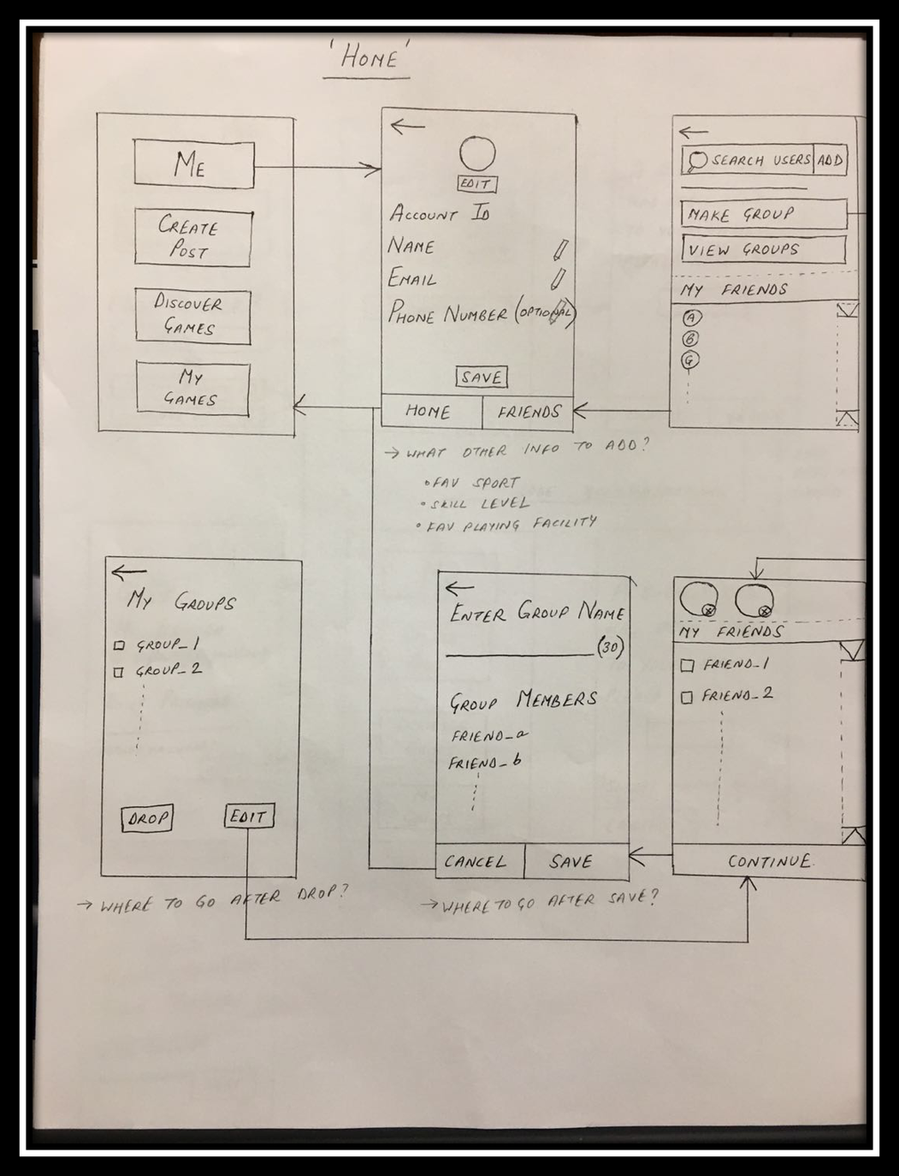

**Create Post**

This part is mainly for organizers who want to make posts to invite other(Figure 5). First of all, organizers can select games.

Initially, WeBall provide 5 games, which are most popular games from our first survey result. Then, organizers can select time and location. After that, organizers choose number of players that want. At last, organizers can choose to post to public or private.

Once they choose public, everyone can see their posts. Or they can choose private which certain people can see their posts. Organizer also can type in comments for more detailed information. For example whether facilities are offered.

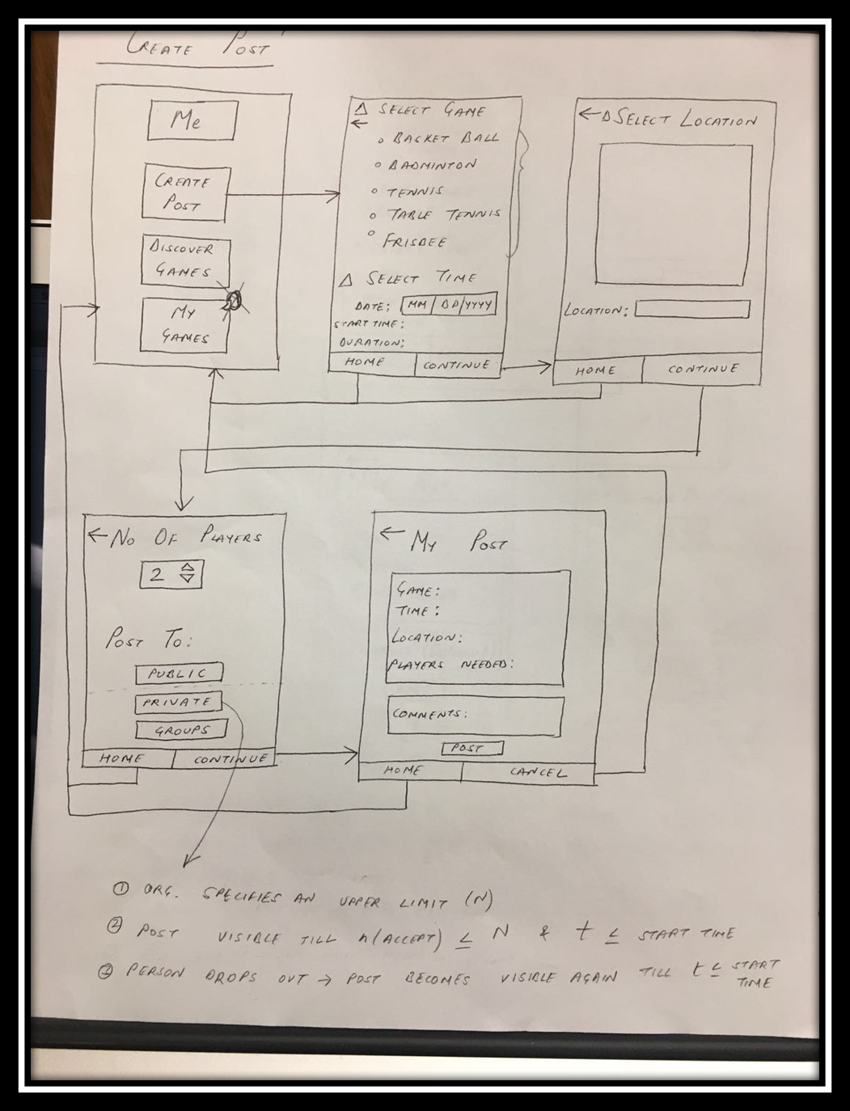

Figure 5

**Discover Games**

Users can discover certain games with certain time once they click “Discover Games”. Just like “ Create Post ”, users can discover certain games with certain time they want. And as long as the number of players is not full, and the post is not closed, users can join in.

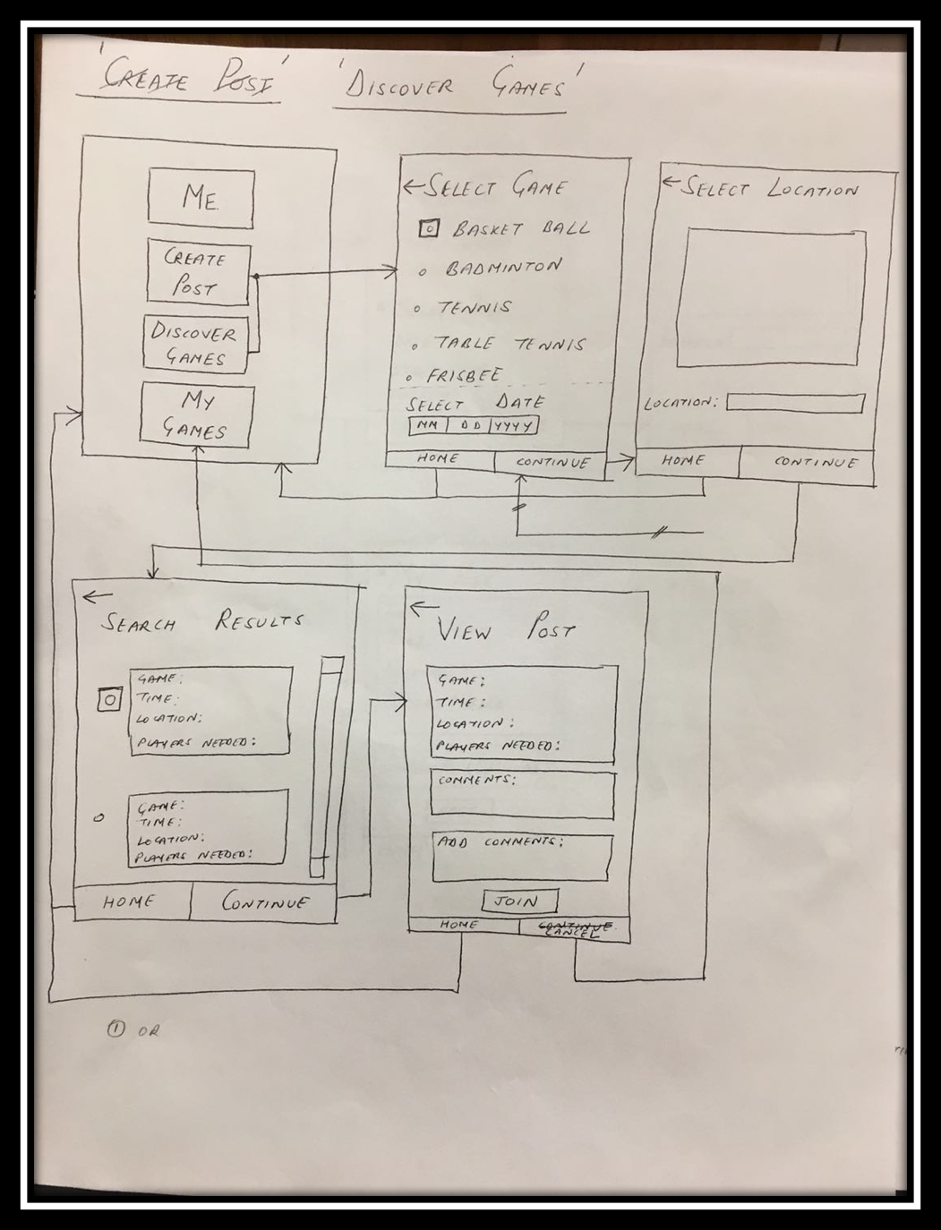

Figure 6

**My Games**

Users can view their upcoming games in My Games. Users can view whole informations about the games they want to join, including the type of games, time, locations and number of players.

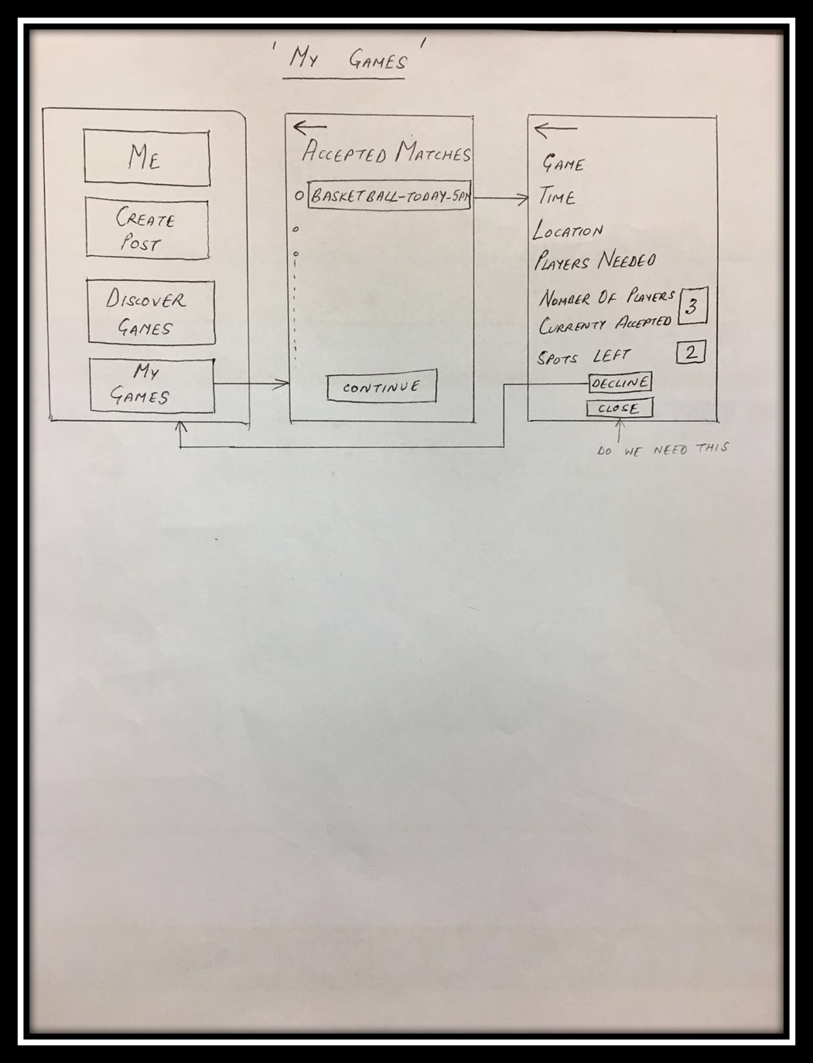

Figure 7

**User Interface: Refined**

After paper prototype is done, we handout survey2 and refine our UI design and transform it from paper prototype to UI by using ionic creator . Then we invite some people to do user test

We make some changes according to the result of survey2 and user test. We also include those abstract from survey1 but we forgot to do in paper prototype.

To make our UI style uniform, for each button bar, we always put “cancel” button as its right part while “continue”, “save”, “post” buttons as its left. In paper prototype, not all pages have cancel or home button. Since several users felt them lost in process and can not go back to initial step on each scenario, we add cancel button on every page so that user can cancel their process at any step and go back to the main page of each scenarios. We also add home button on every final step of one scenario if it not jump to home page automatically.

**Sign Up**

This part is as same as what we have in paper prototype.

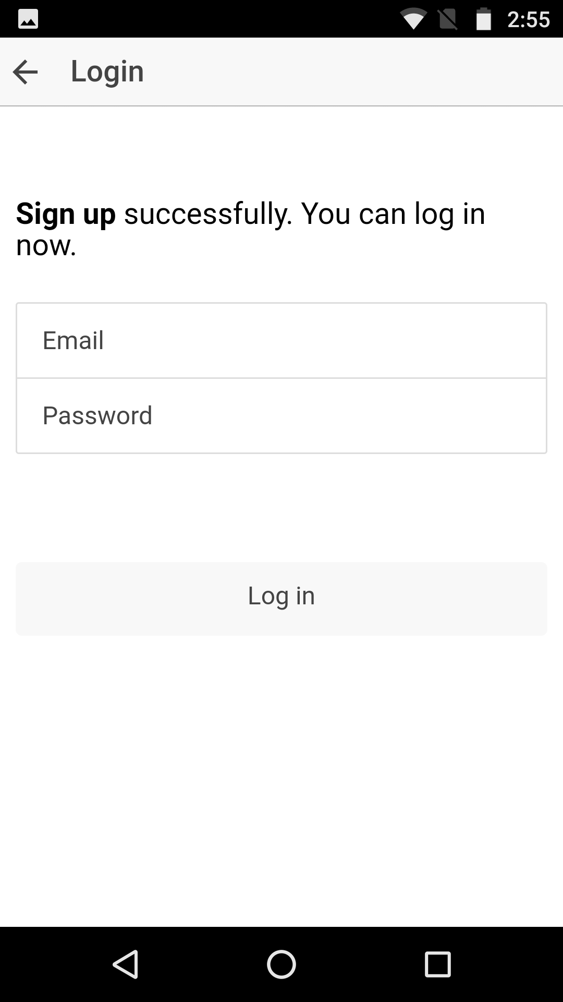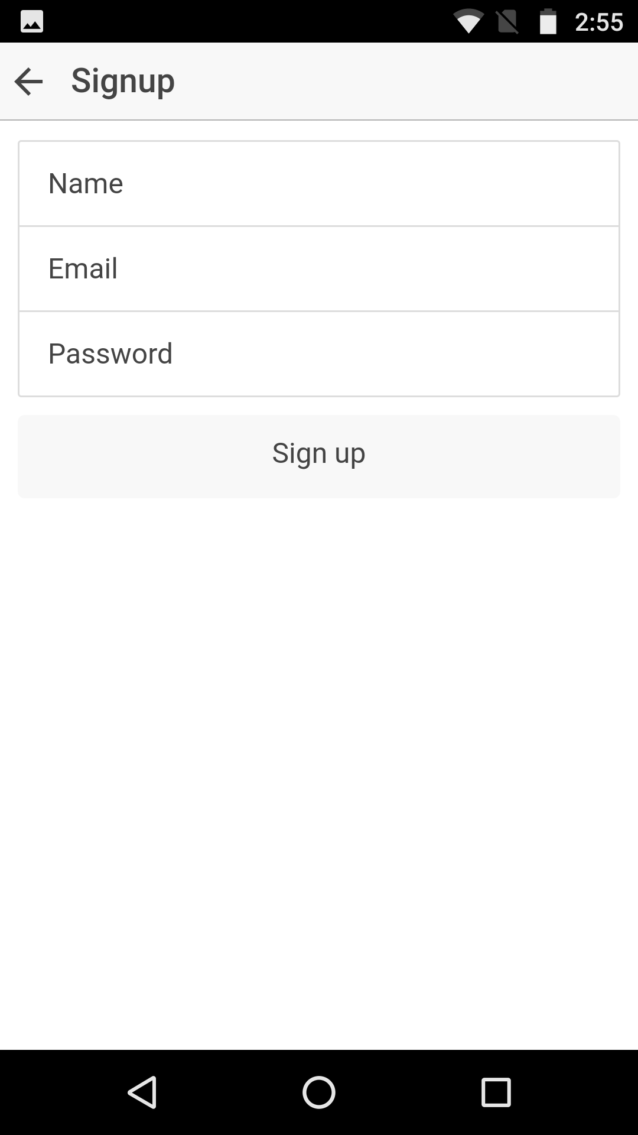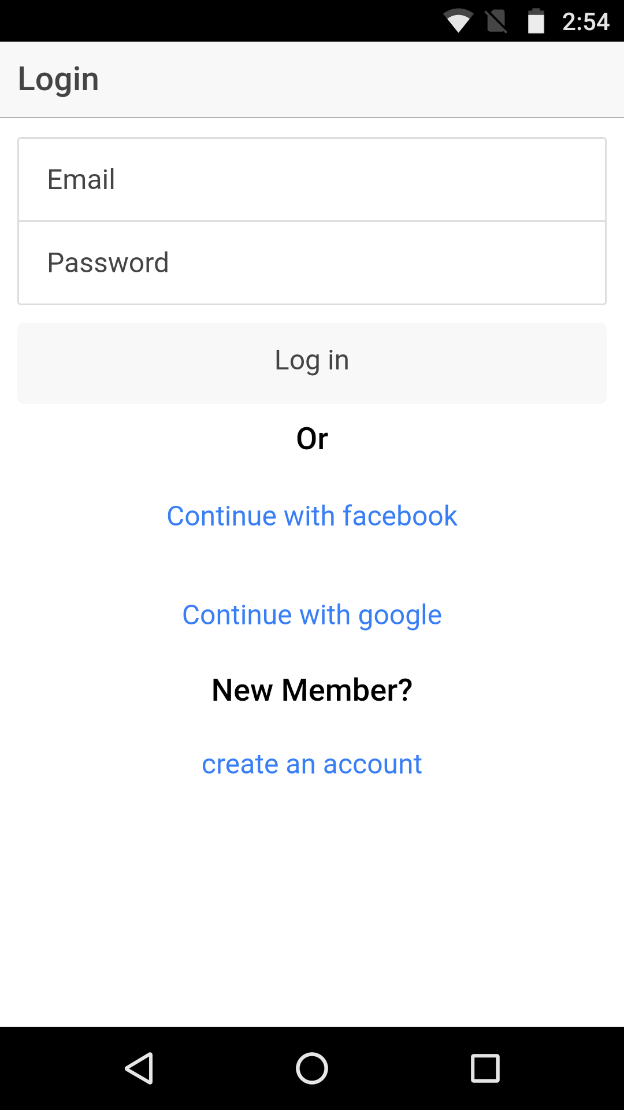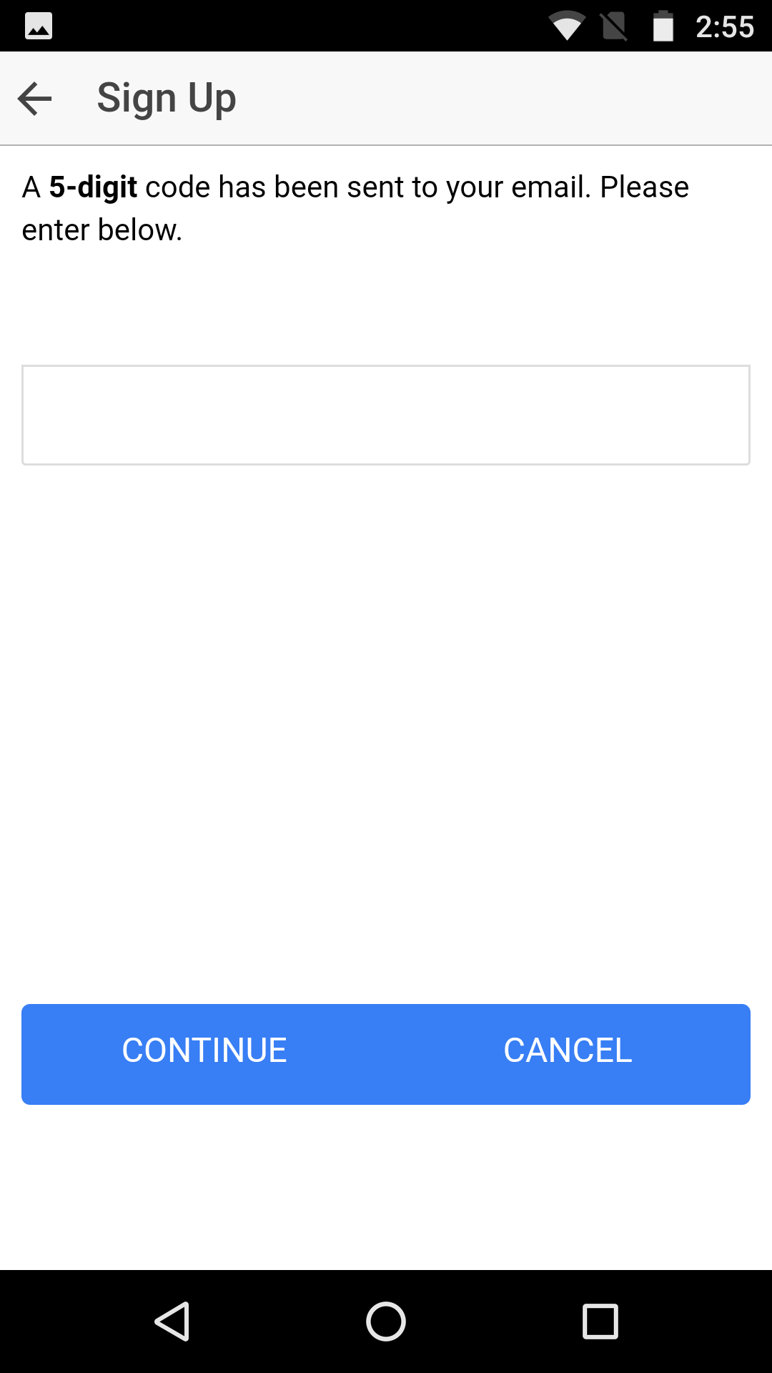

**Home Page**

There are five buttons in home page. We add “Log Out” button this time .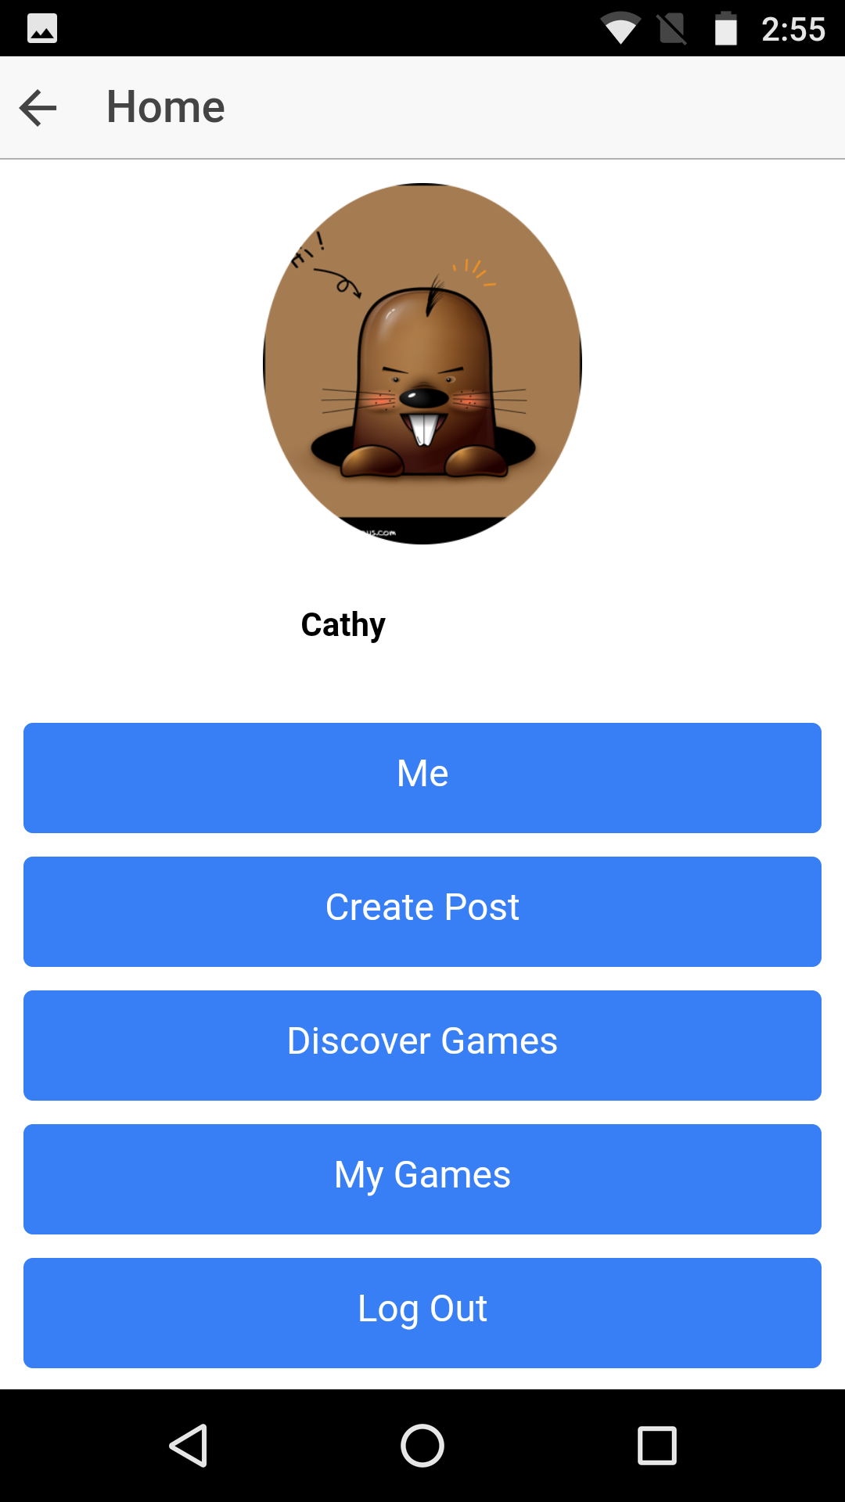

**Me**

We add “more about me” for the user to show their favorite sports, skill levels or such thing so that other users can know this user better. We add this function because in survey1 27.9% people select the factor of dissuade them from playing a pich up game to be not aware of people’s skill level, and 33.3% people feel that skill level will make them more confident of playing a pick up game with someone they do not know.

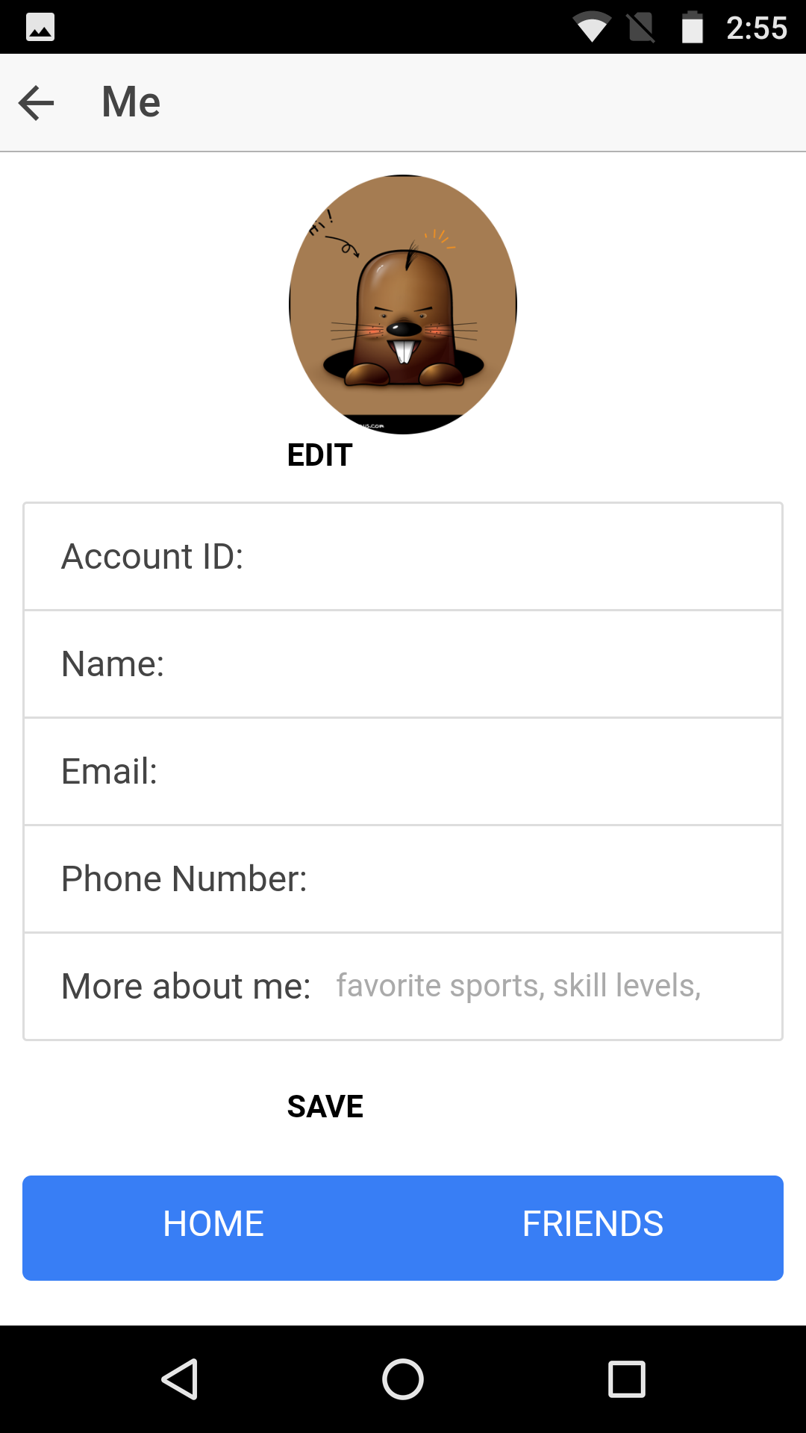

**(1) Friends**

Here is a search engine on the top of the page. The user can search for other user by user id or name and then invite him or her to be friends.

Here is a list of my friends. If clicking on one friend’s name, the friend’s profile is shown.

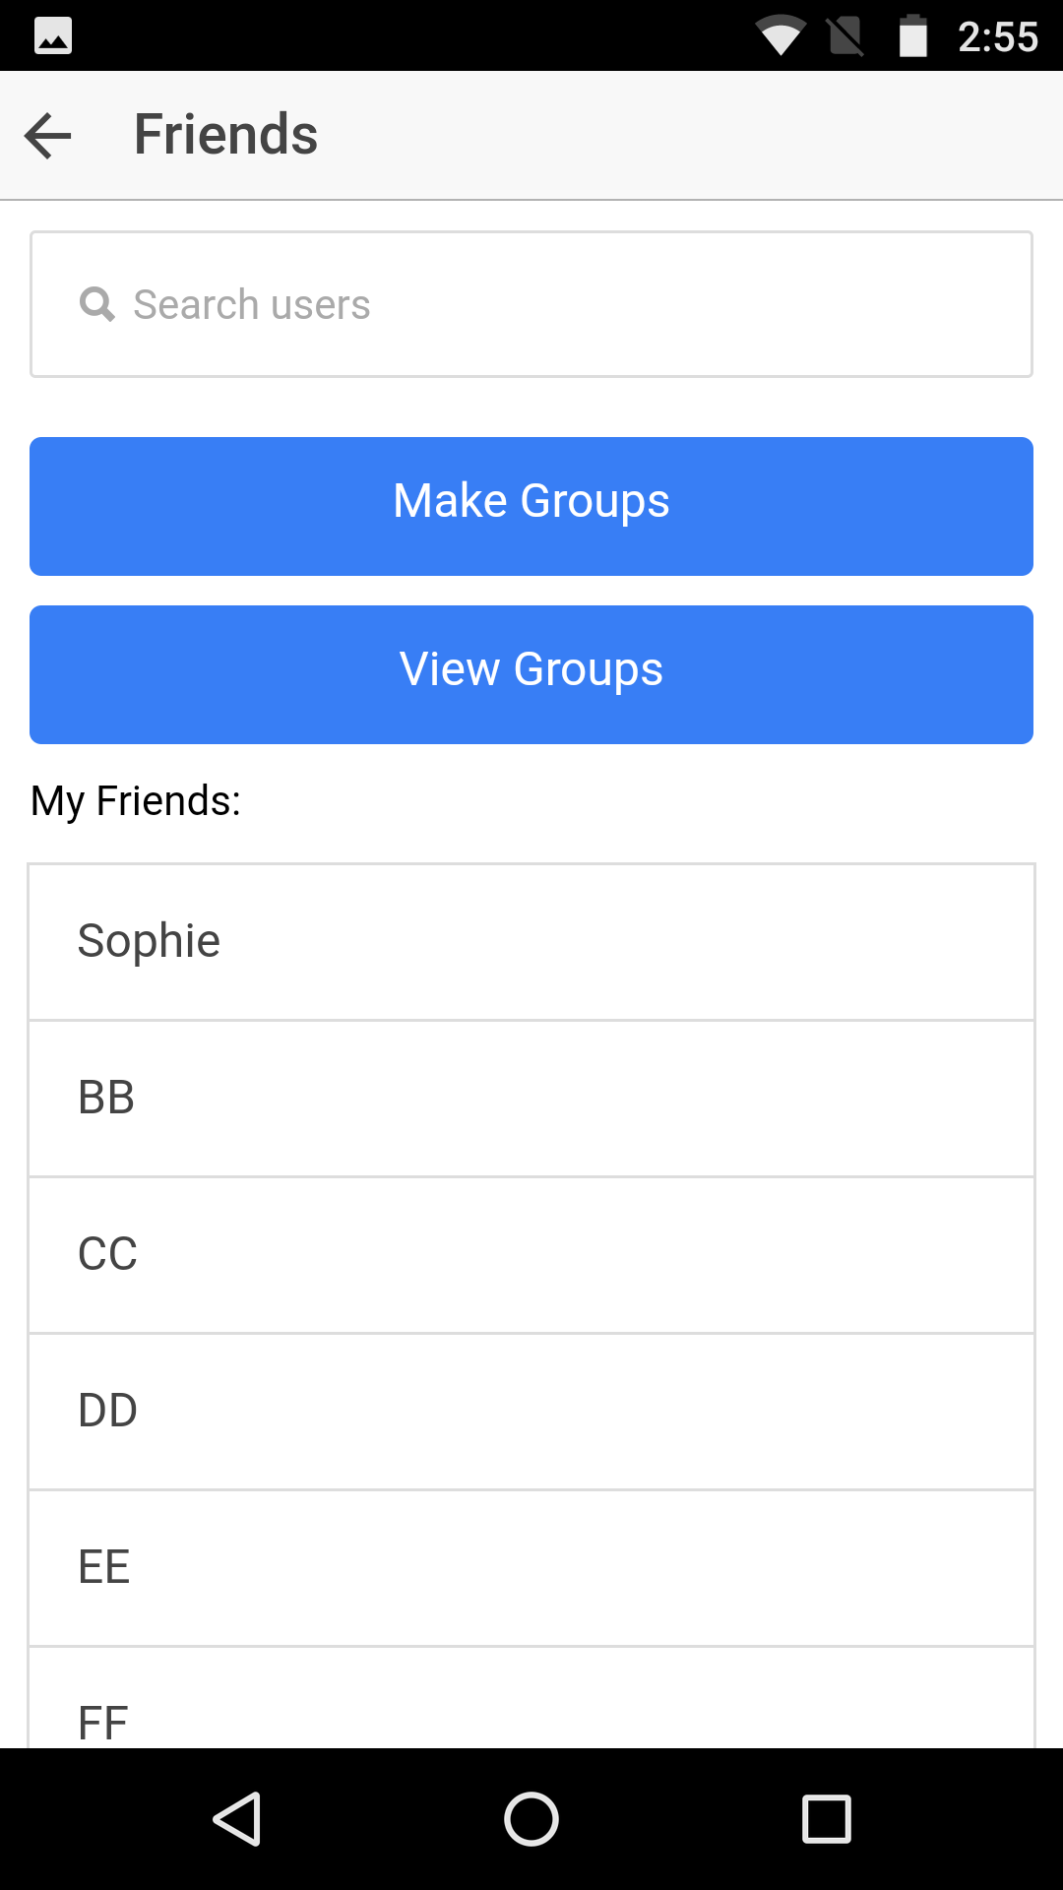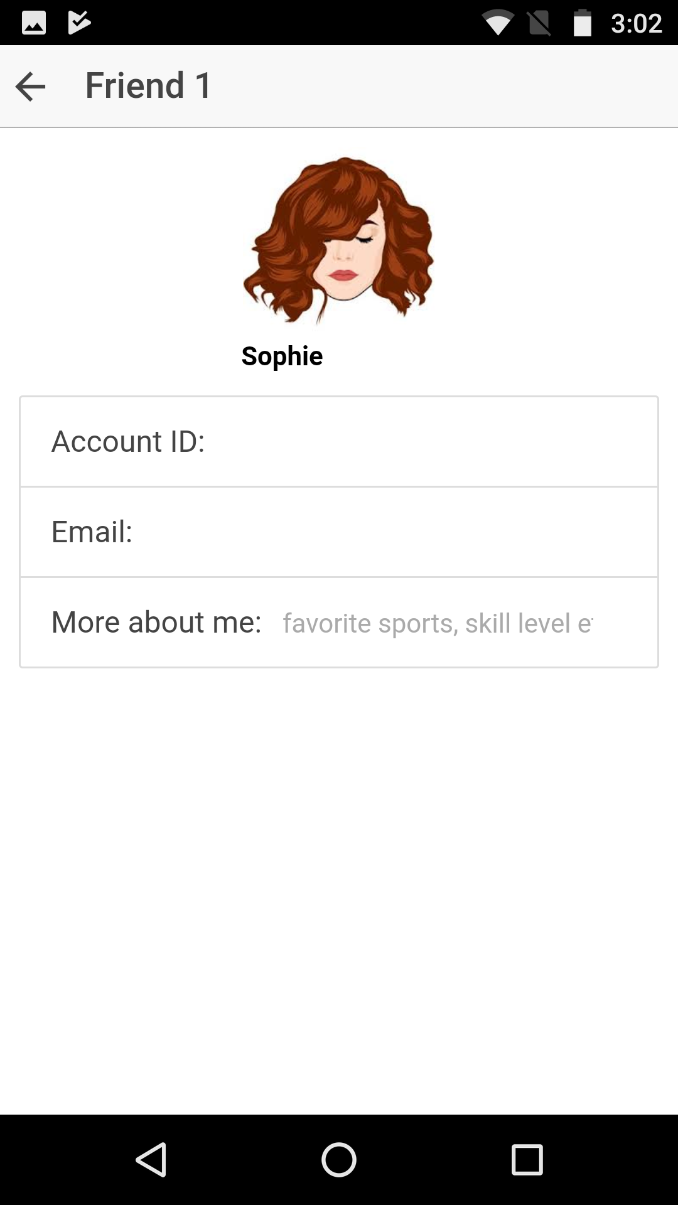

**(2) Groups**

**(2.1) Make Groups**

On the main page of “Make Groups”, the user can select people to be group members. Once saved, this group is created and the page will go back to “Friends” main page.

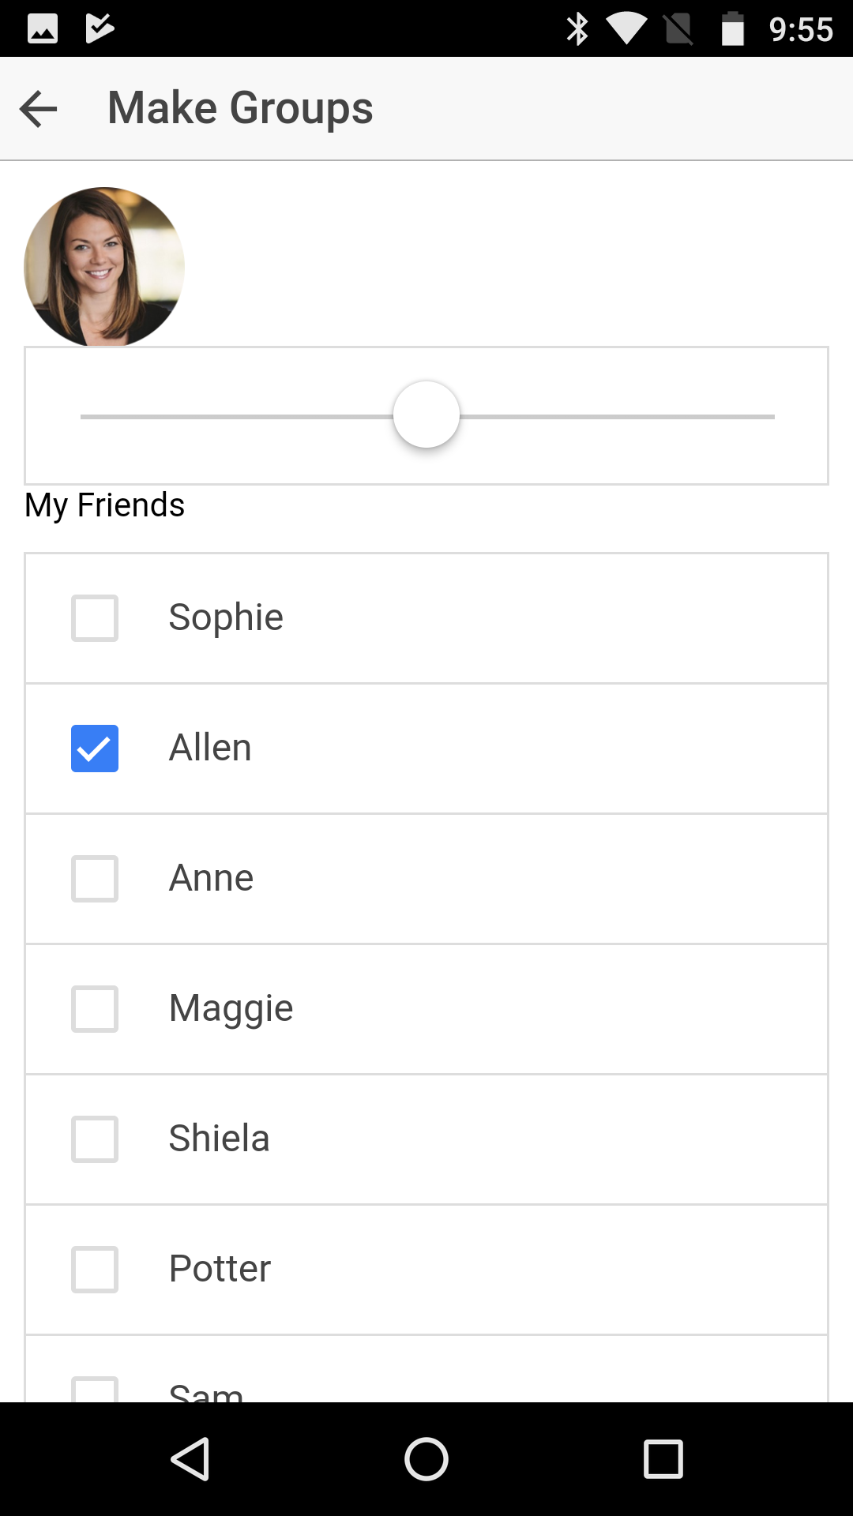

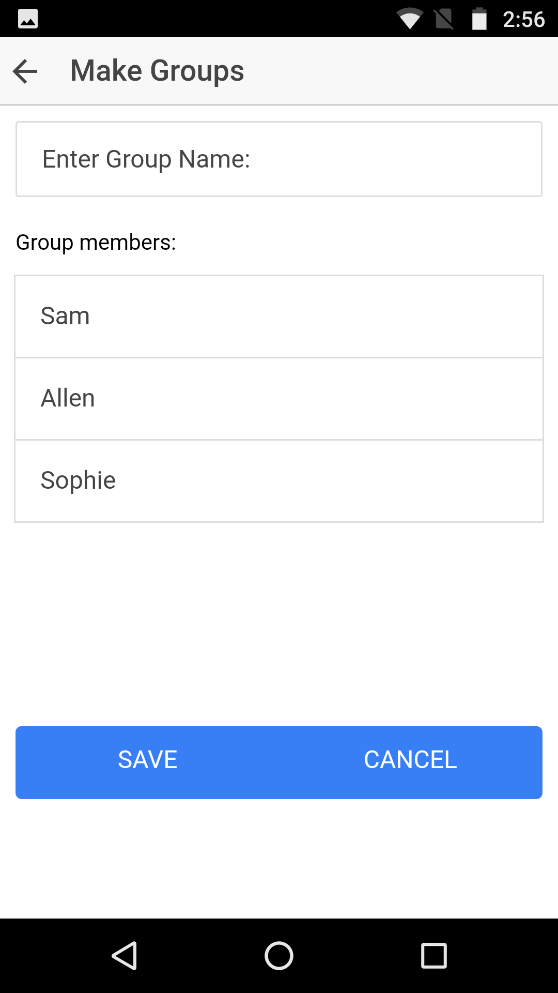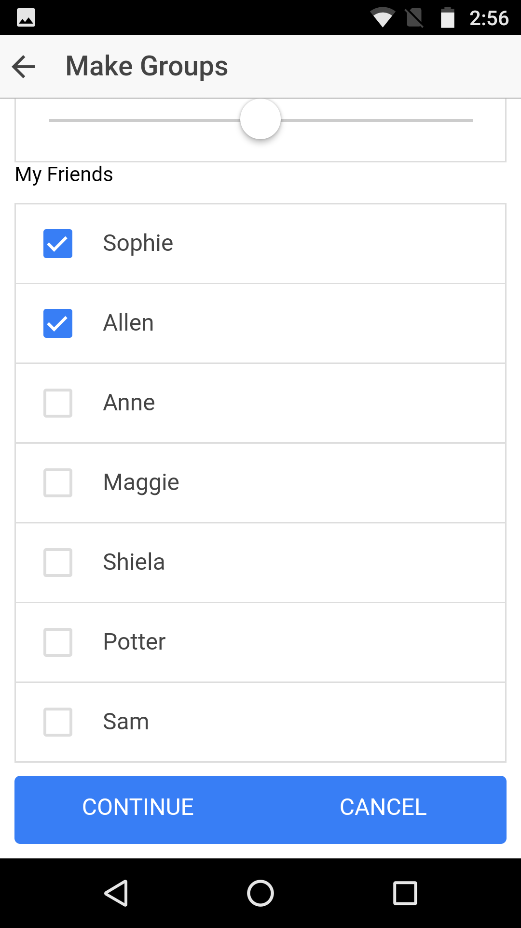

**(2.1) View Groups**

On the main page of “View Groups”, the user can select one group and then drop or edit this group.

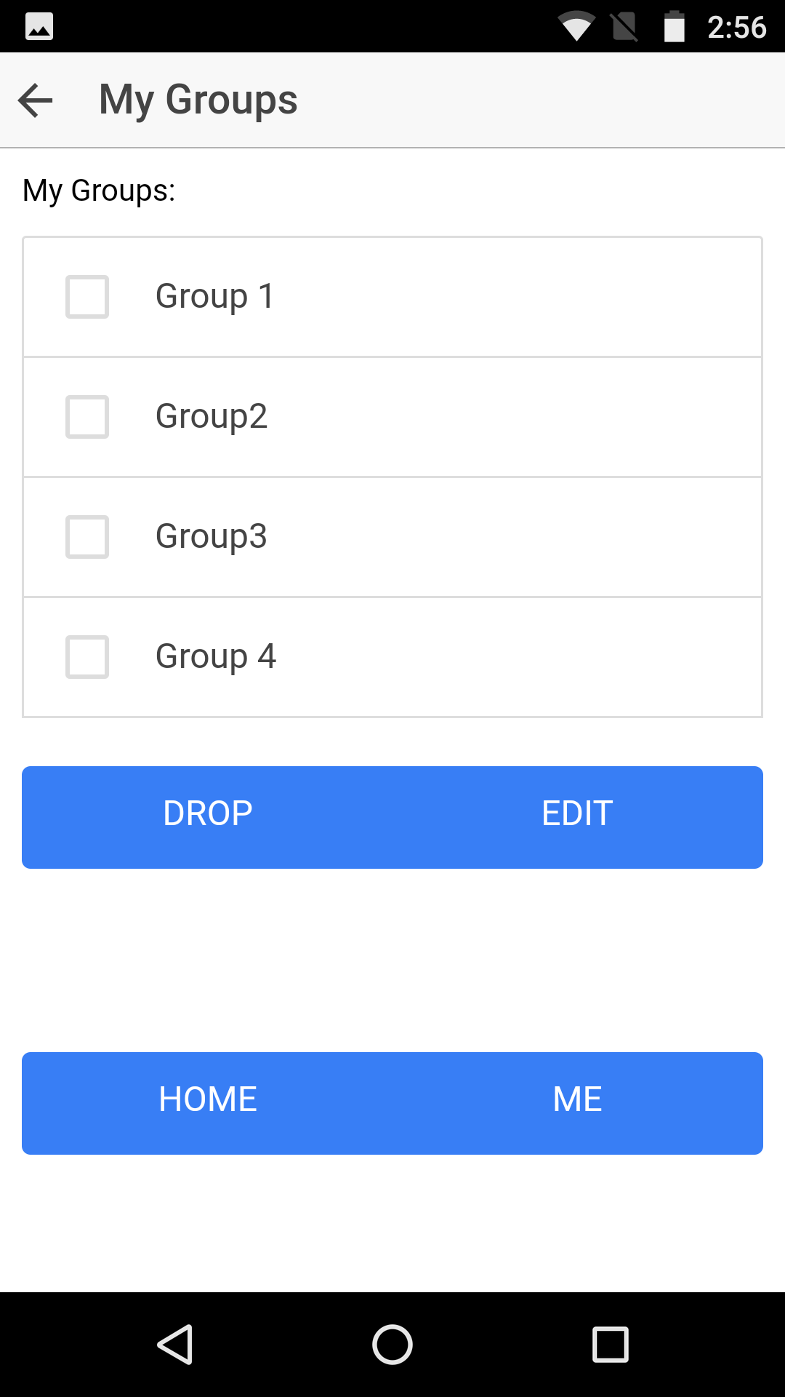

**(2.1.1)Drop Groups**

Just click on drop button, a group will be removed from the group list on this page.

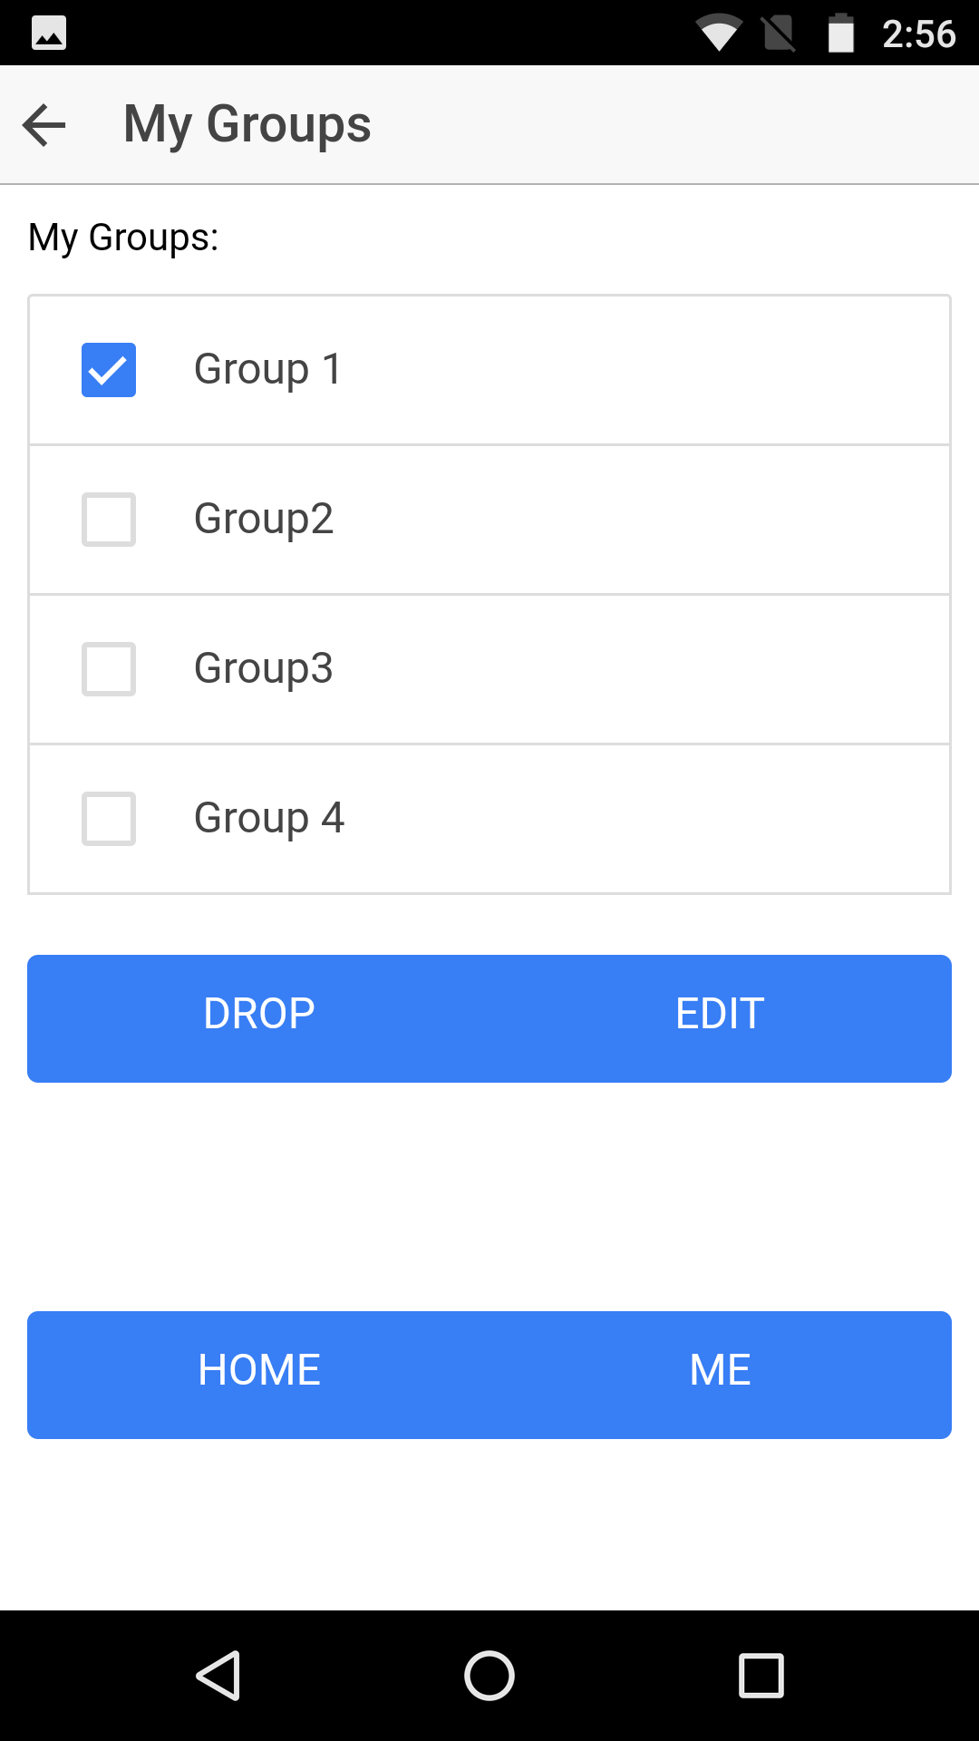

**(2.1.2) Edit Groups**

Clicking on edit button, a page similar to “make groups” will appear. Use can delete member or add member, and then can change group name.

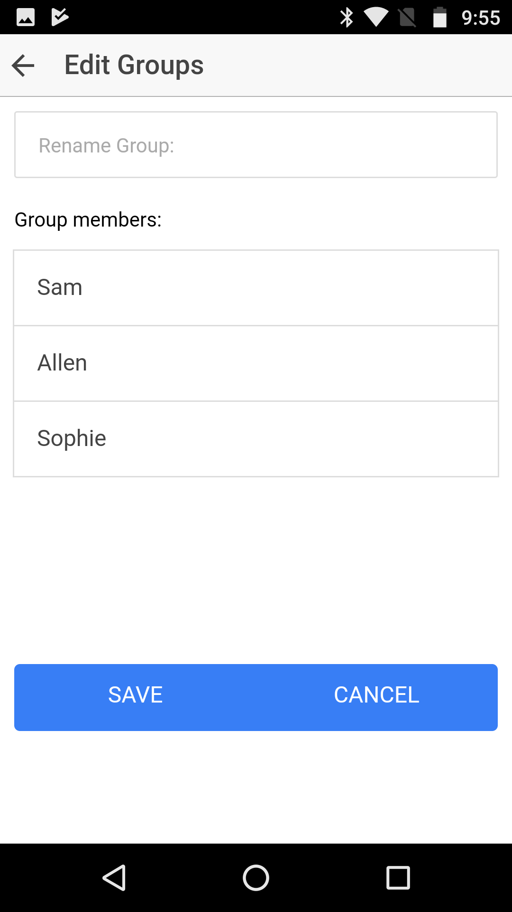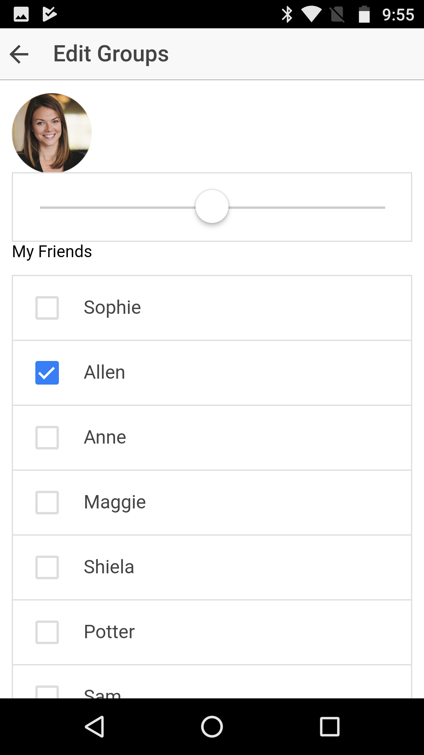

**Create Post**

Compared with survey1, in survey2 we provide more options in the question: What is your favorite sports, especially those popular in America. We also ask people how many types of game they want the list to show them. According to the result, the list of games for creating post and discovering game now only include 4 different games.

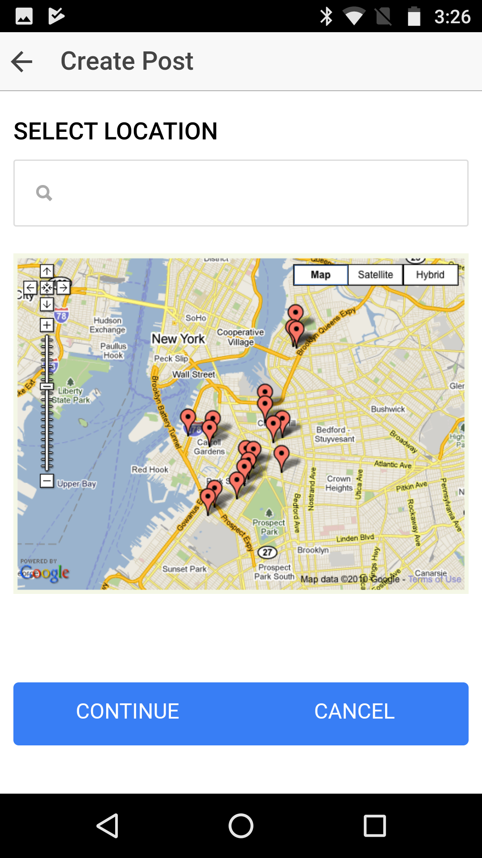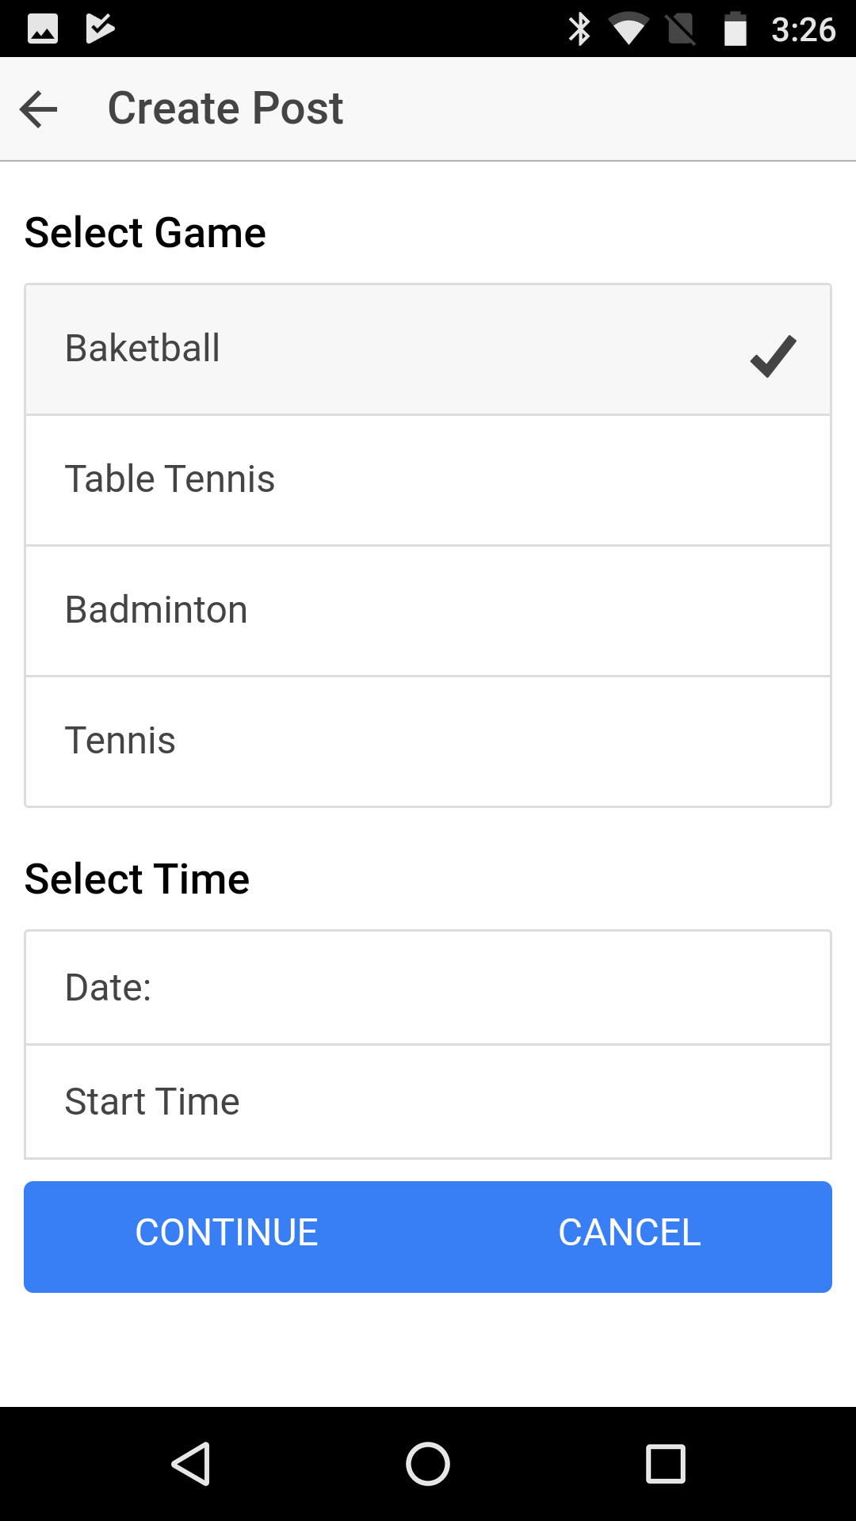

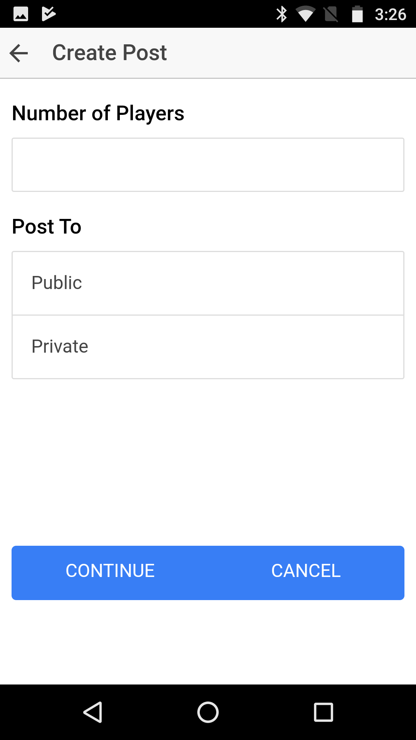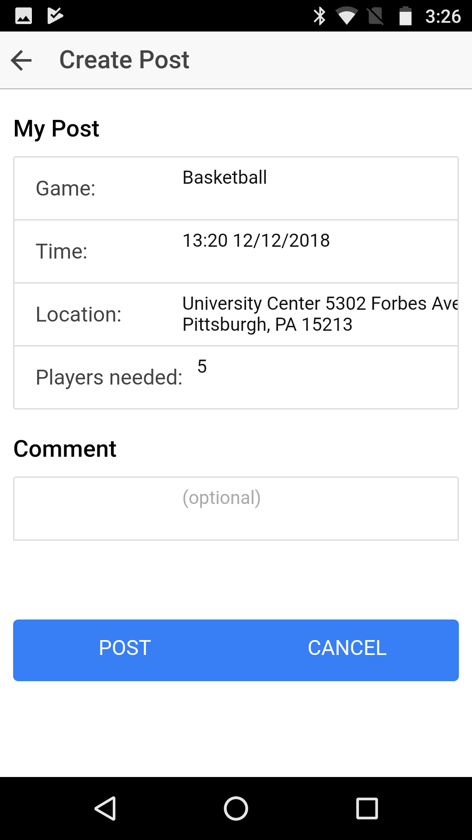

**Discover Games**

Similar as the process of make post. By clicking on one game in discovered games, all of the information about this game is shown.

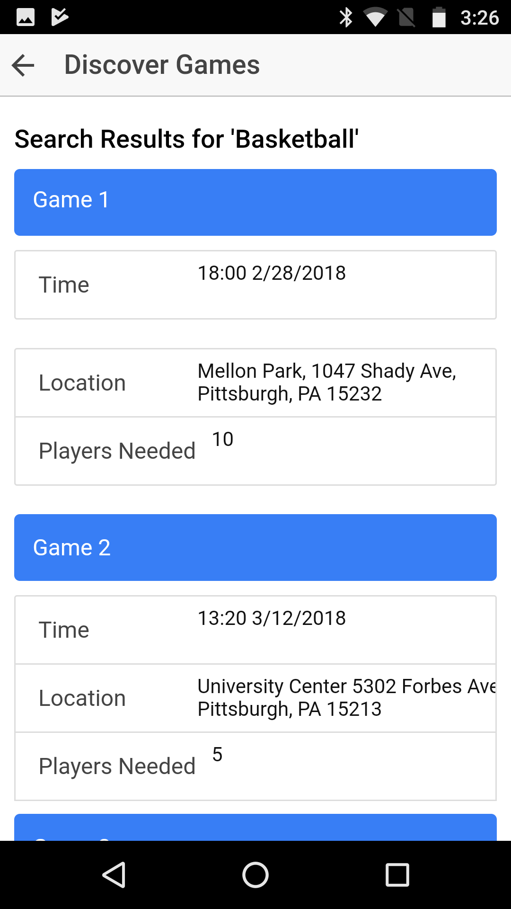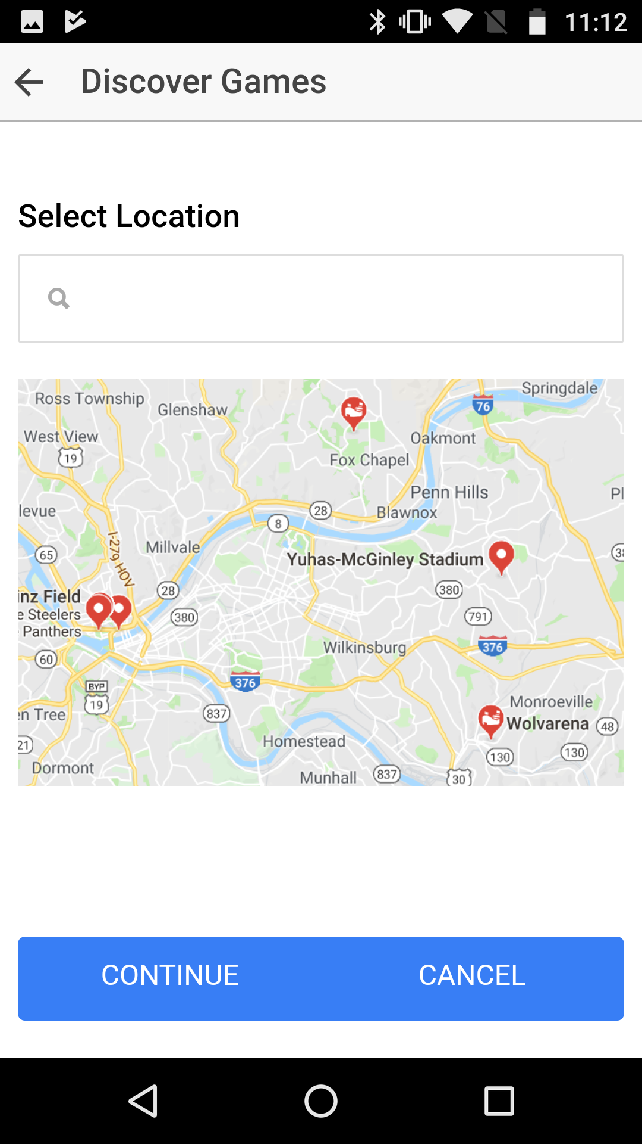

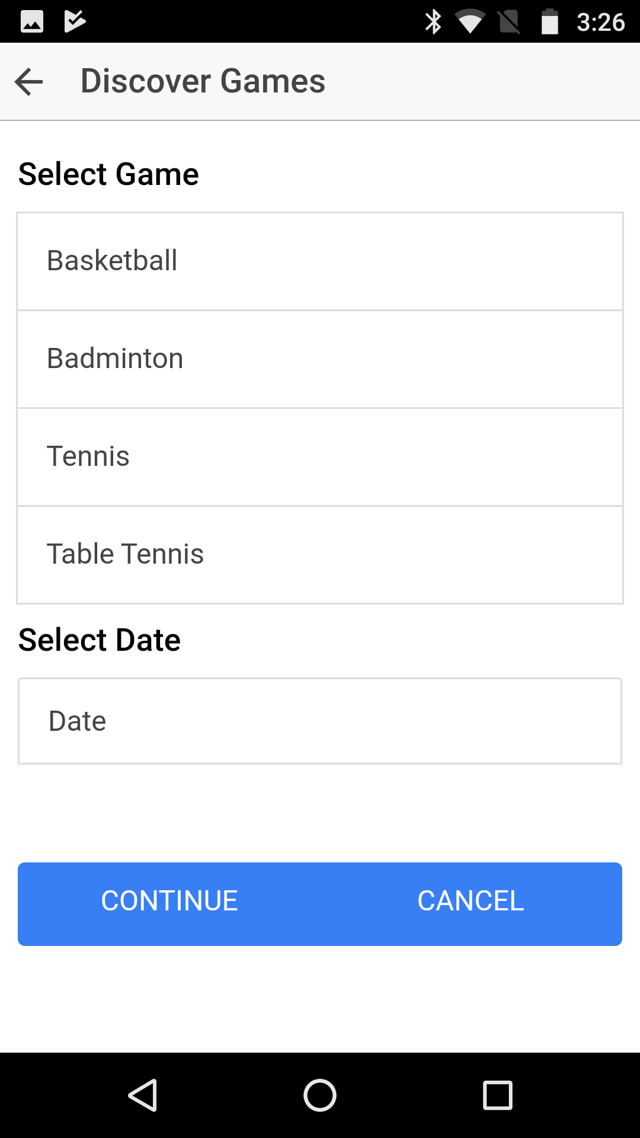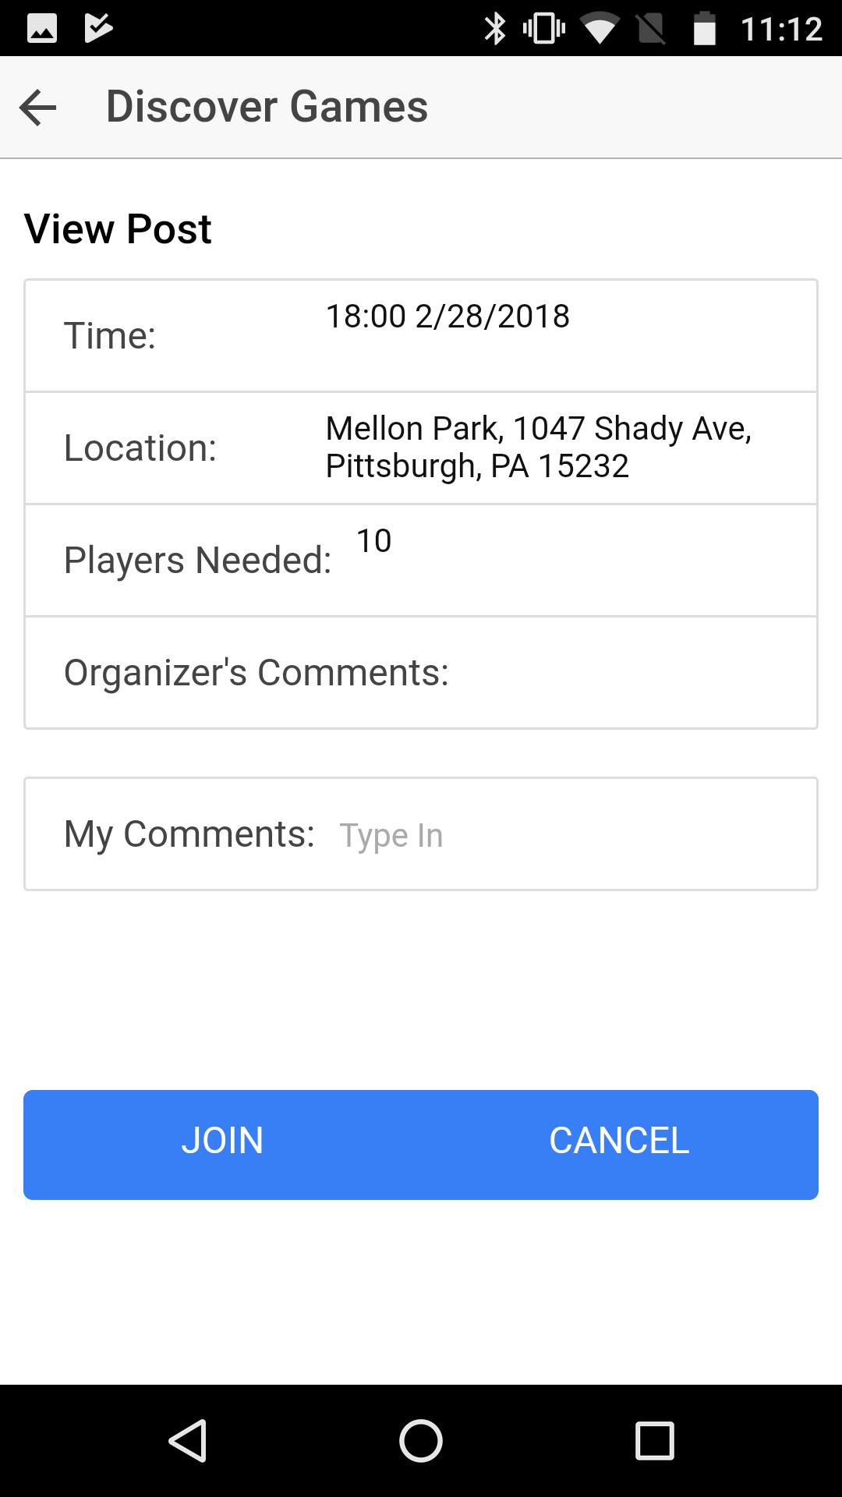

**My Games**

In paper prototype, if the user is an organizar, then for each game, the user should close a post so that no more people can join in this game. But according to the result of question 11 on survey 2, 35.3% people want a post not to be closed until the game ends and 23.5% people want it not to be closed until game starts. So we decide declining the close button for an organizer and let our system to close posts until game ends.

In paper prototype, we assign different colors to games joined as an organizer and games joined as a participant because page for a organizer contains close function. Since now an organizer can be treated equally as a participant after the organizer finish making post, we delete that color function.

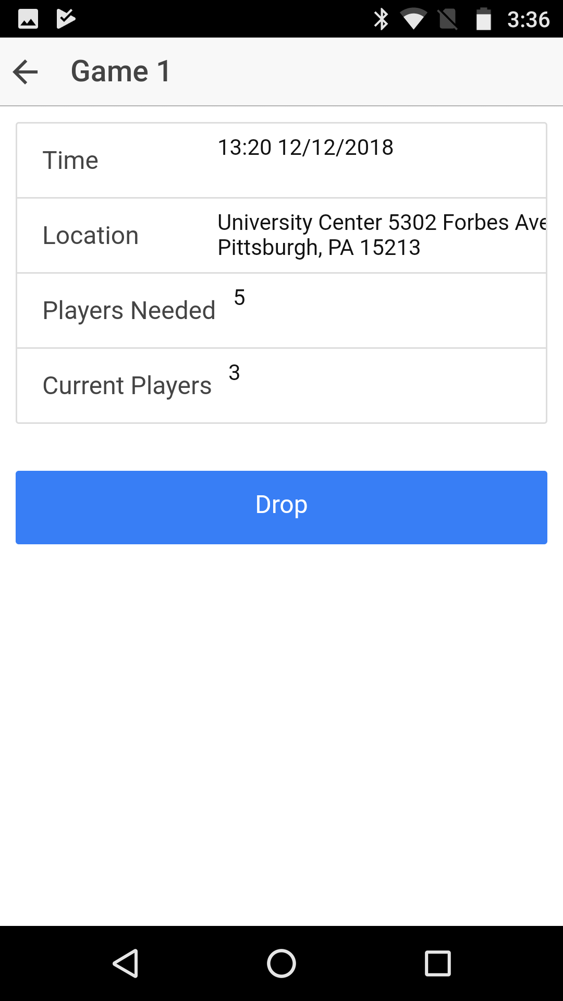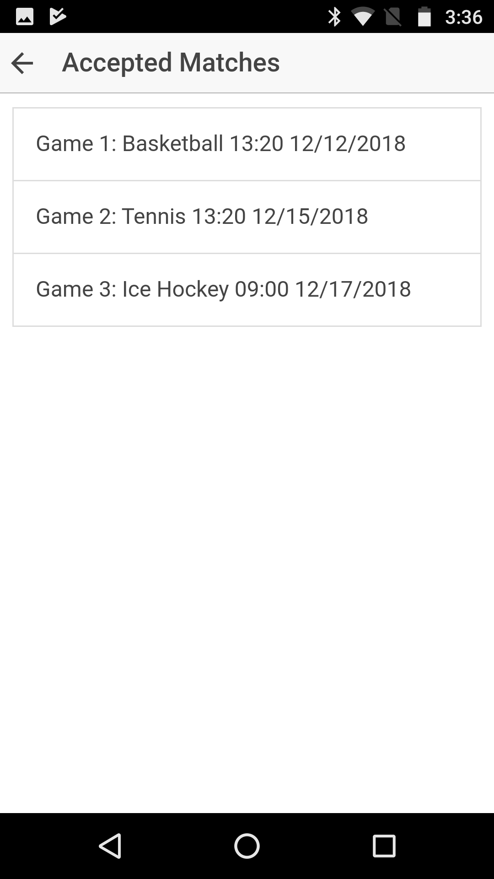

In user test, a user complained about no confirmation after clicking on dropping, so we add a drop confirming page to avoid incorrect action. After dropping a game, the game is removed from the list of accepted matches.

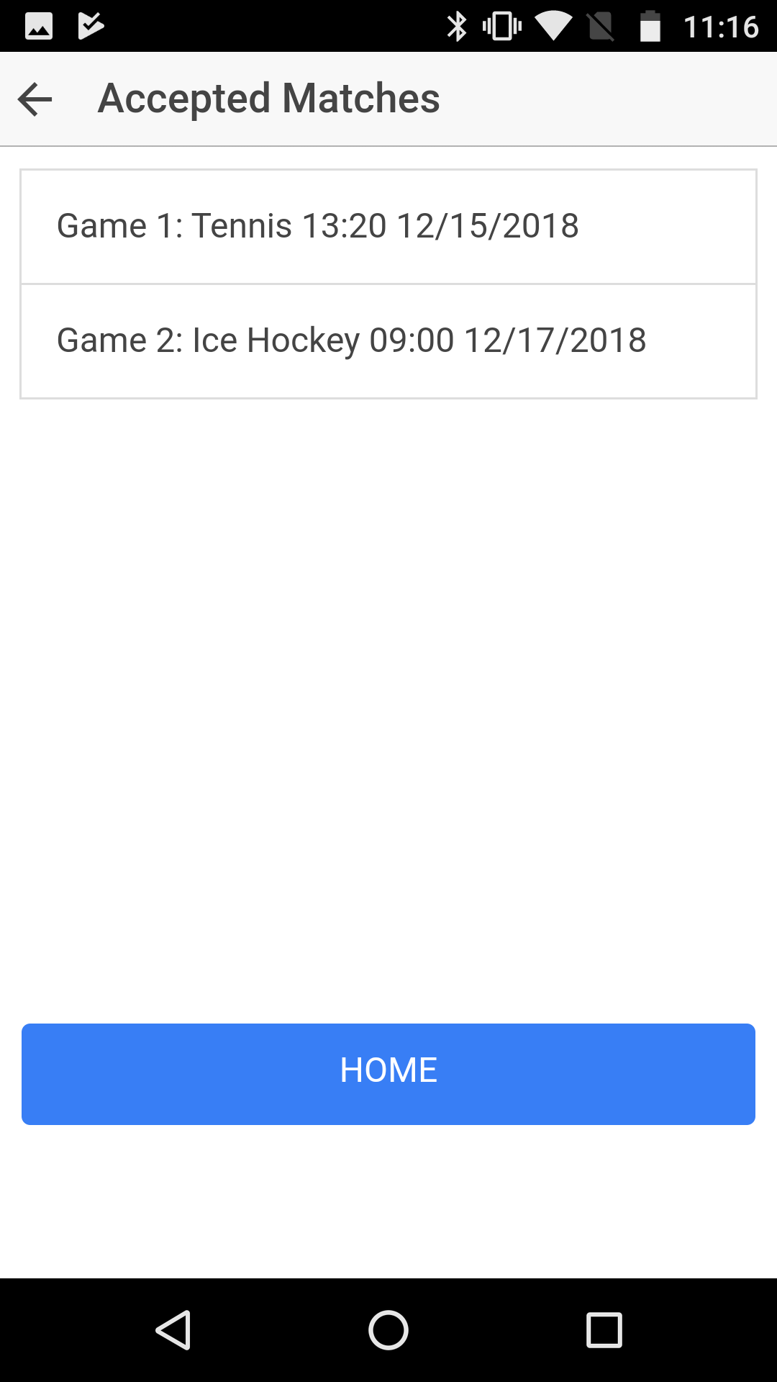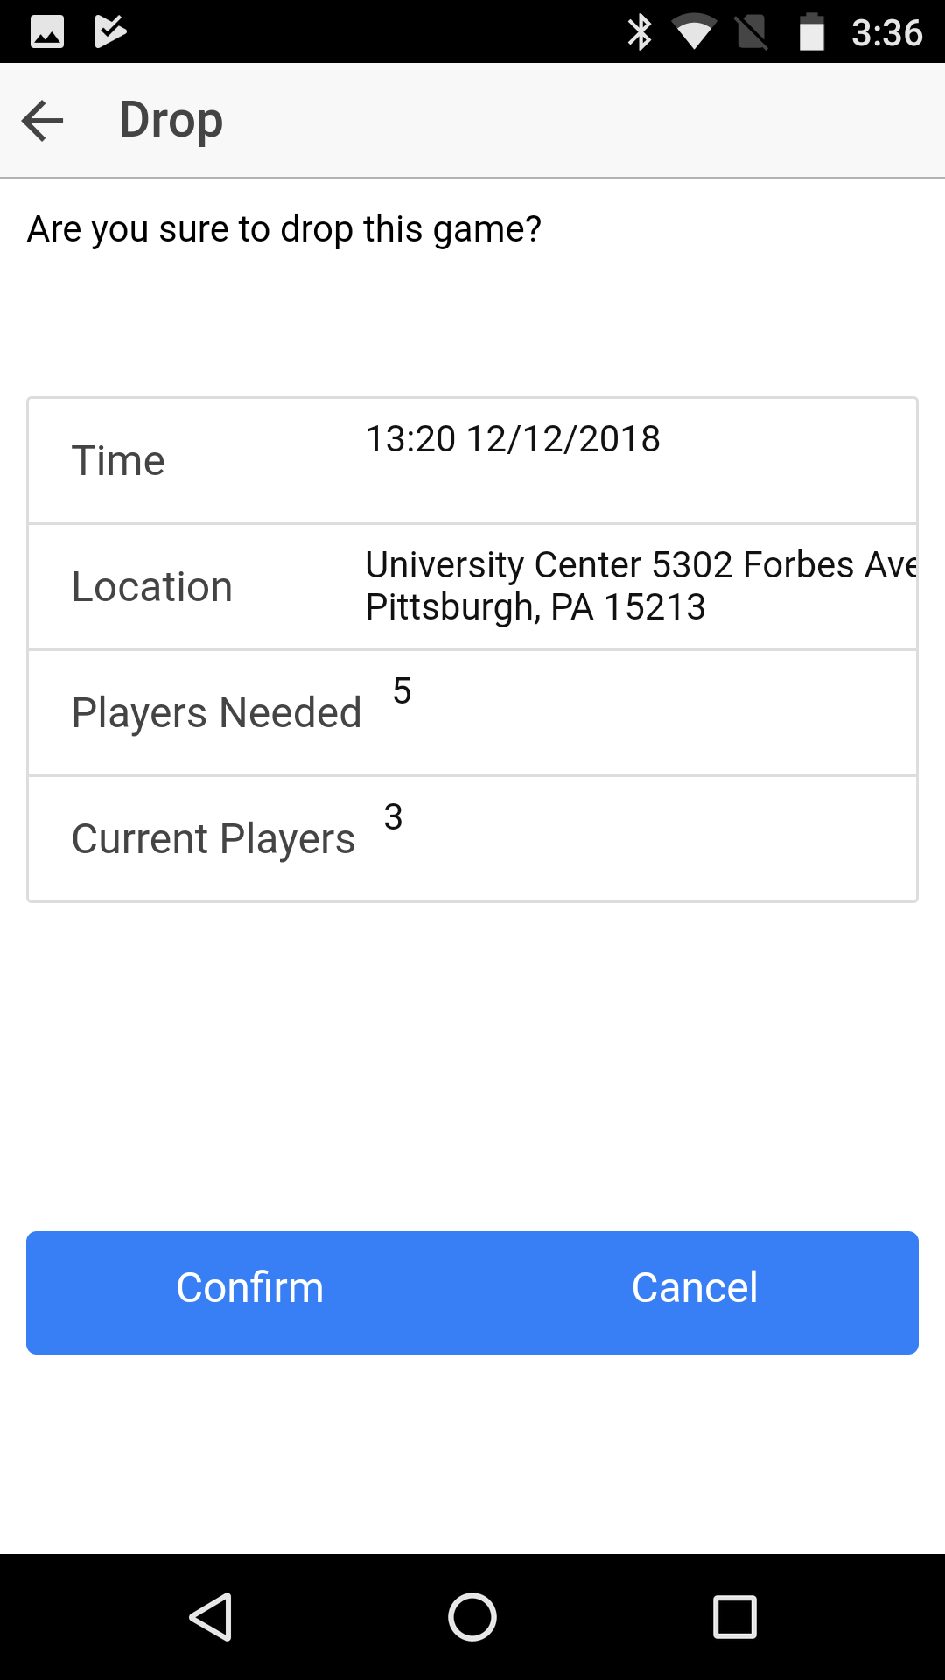

**Usability Evaluation**

During the second half of the semester, we invited 5 interviewees who like to play different kinds of sports when they are free to try the above user interface and got some feedback from them.

A: Aiwu, a 48 years old college professor who loves to play sports, especially tennis in his spare time.

B: Willy, a 25 years old software engineer who plays basketball with colleagues and friends on weekends.

C: Rebekah, a 22 years old ECE senior who loves all kinds of sports.

D: Ashley, a 24 years old ECE master who plays badminton occasionally.

E: Chris, a 23 years old ECE IMB student who loves all kinds of sports.

1. Sign Up and Login Page

All of our interviewees figured out how these pages work in a short time.

1. Home Page

Interviewee B said he would prefer to have Discover Game button as the first button in the page as the first thing he wanted to do after logging in would be finding available games instead of going to his profile page. Interviewee A and E liked to have the My Games button inside the Me.

1. Me Page

Interviewee A and E were trying to find the button that could lead him to all his games in the Me page.

* 1. Friends Page

Interviewees B and C said they would like to chat with their friends inside our app. They had to switch to another app to discuss about upcoming games with their friends otherwise.

* 1. Group Page

Interviewee liked this functionality. They figured how to use this functionality quite quickly.

1. Create Games

Interviewee B complained about there were too many pages to go through in order to create a new game. Interviewees A and D asked about what was the difference between posting to public and to private. They found the names were not intuitive.

1. Discover Games

Previously, we were giving users the options to discover games within a certain timeframe or games close to a certain location. However, all of our interviewees do not find this workflow makes sense. Both interviewee A and C even asked about why it turned to the result page right after they selected time and date, because they were expecting the 'Select Location' page. They thought were some bugs and were going back and forth between the pages.

1. My Games

Interviewees A and E were confused by getting a list of games after opening the My Games page. From the name, they were expecting a page containing all the games that they organized instead of also seeing the games that they joined.

**User Interface: Refined2**

In the second half semester, We invite some students to use our app which has the user interface just as above. Then based on feedback and suggestions of them, we mo dified our user interface.

**Welcome page**

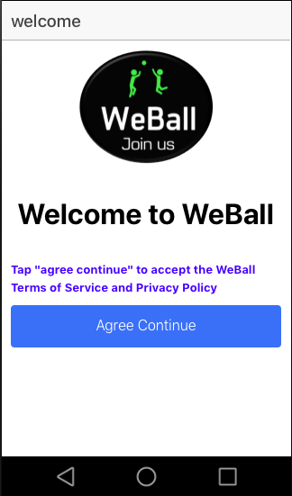

Figure 1

As figure1, this is the welcome page of WeBall. When users download our app and open it, the users has to read and agree the WeBall Terms of Services and Privacy Policy. WeBall Terms of Services are rules by which one must agree to abide in order to use WeBall. A Privacy Policy agreement is required by law if WeBall collect or use any personal information from WeBall's users, e.g. email addresses, first and last names etc. The purpose of this agreement is to inform users about the collection and use of personal data of users.

**Log In**

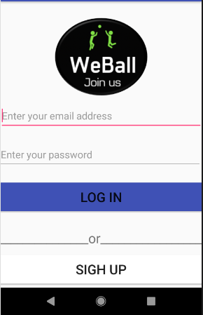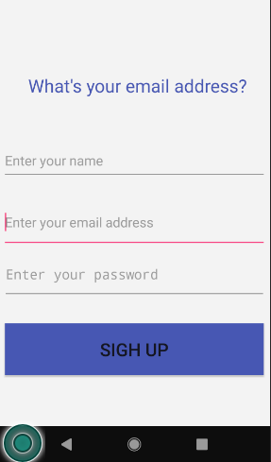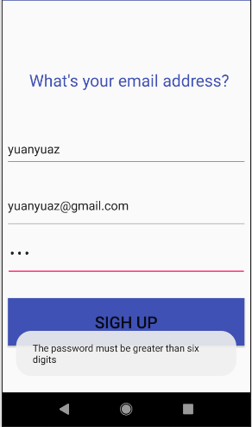

Figure 2

Figure 2 is log in and sigh up page. Users can use their valid email address to sigh up and login. In order to protect users account, we require users' password must be greater than six digits.

**Home page**

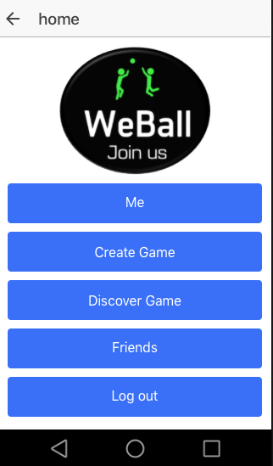

Figure 3

Figure 3 is WeBall's home page , which includes 5 buttons: Me, Create Game, Discover Game, Friends and Log Out. The home page clearly indicate the main functions of WeBall. It's easy for users to choose what they want to do using WeBall. And from our usability test, we found that it would make more sense to move the My Games button into the Me page because it relates to a particular users.

**Me page**

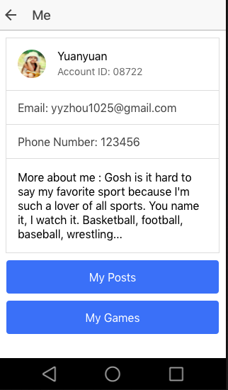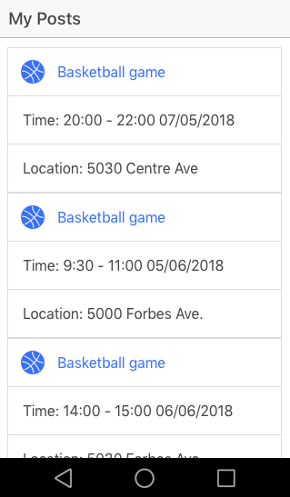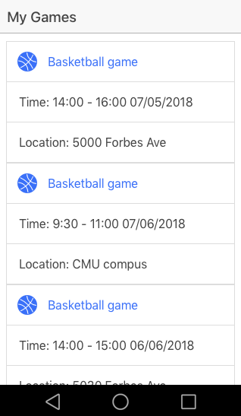

Figure 4

We changed the layout of WeBall's Me page. This new Me page is more realistic. The new Me page has more space for "More about me", so the users can edit more things about them. According to the usability test, users would prefer to be able to differentiate between the games they posted and the games they join as participants. Thus, we added two buttons bellow: My Posts and My Games. My Games includes games which the user want to participate. My Posts includes games which the user is organizer who wants to invite people to games.

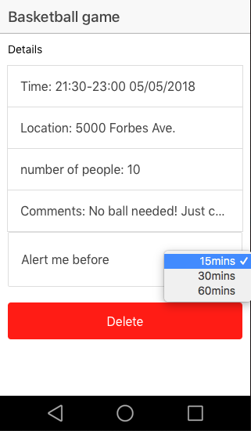

Figure 5

Once the user click one specific game, like a basketball game, it will have an interface as above show the details about the game. The user can clearly see the time, location and number of people of the game. Also, the user can edit Comments and choose when they would like to be alerted. We added the alert feature based on the suggestion from a usability test interviewee.

Create Games

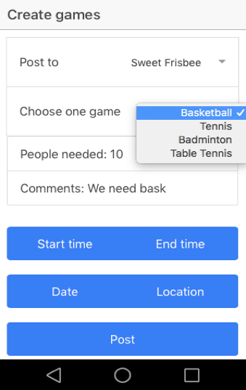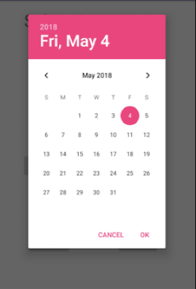

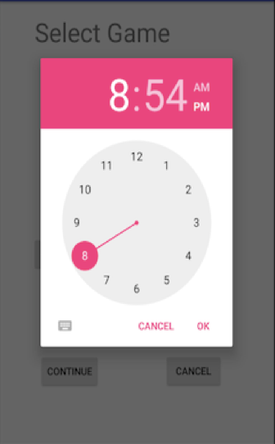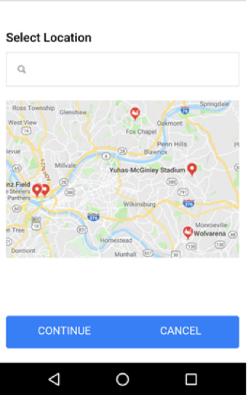

Figure 6

In Create Games part, users can create their own posts to invite people to their pick up games. Users can choose to post to all their friends or a special groups. It's easy for them to select data/time/location using three buttons in the Create Games page. Also, to make the application more intuitive, we change changed the "post to private" option to "post to a specific group of users". In our example about, the post is being posted to "Sweet Frisbee" group. Moreover, to make WeBall more concise and easier to use, we put all steps into one page instead of making the users go through three pages to make a new post.

**Discover Games**

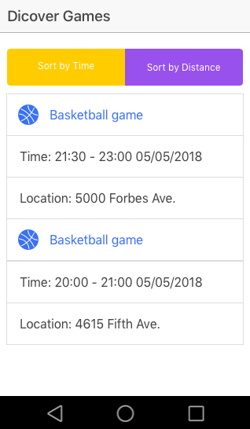 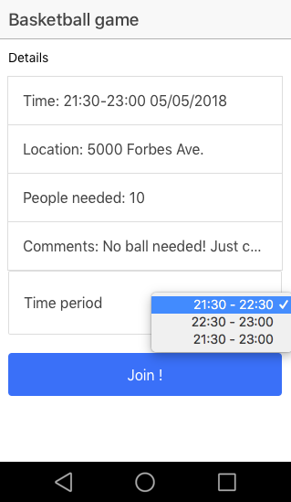

Figure 7

When users want to find games to join, they can click Discover Games in home page. And from our usability test, we have combined discover games by time and discover games by location. Now, users must select both time and location at the same time to discover available game and they can sort the results by either time or distance. It's easy for users to discover games which they can join in. Once users find a game they want to join, they can click into the game and see the details about the game, just like Figure 7 above. Users can choose to different time period according to their time schedule. In fact, time period more than one hour can be split to slots of one hour to allow people join game in different time slot. After users click join button, this particular game will display in their "My Games " page.

**Friends page**

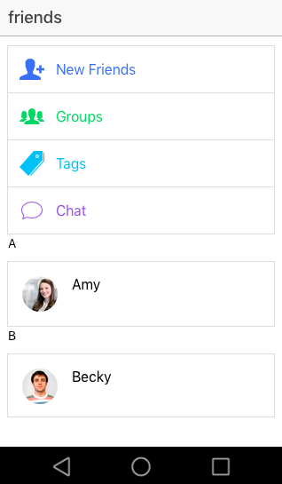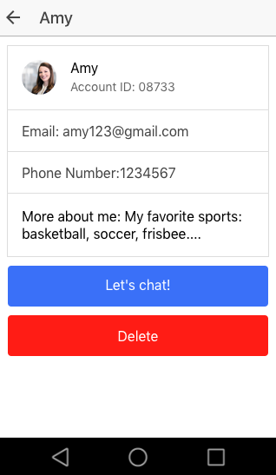

Figure 8

The Friends page displays users' friends according to alphabetical order. When users click one of their friends' icon, like figure8, if users click Amy, Amy's profile page will display. Same as me page, Amy's profile page shows Amy's Account ID, email, phone number and more about me. Users can select chat with Amy or they can choose to delete Amy.

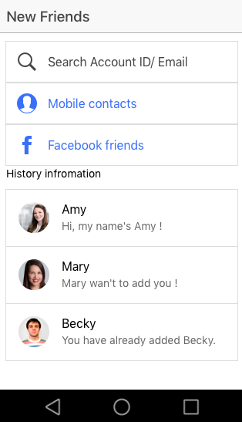

Figure 9

Once users click "New Friends" icon in Friends page(Figure 8), it will display figure 9. Users can search others users by account ID or email. In addition, users can add friends from their mobile contacts and Facebook friends. This page also displays the history of adding.

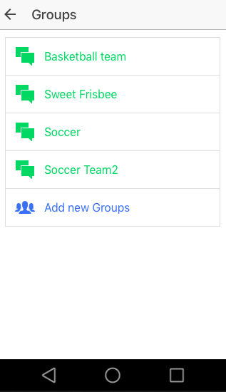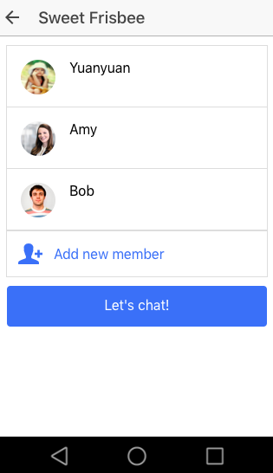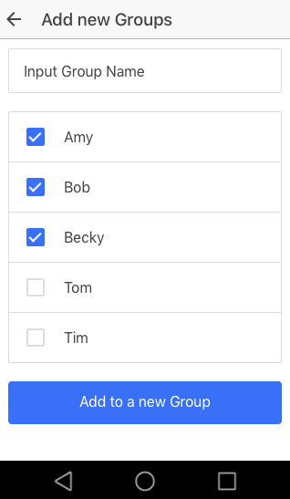

Figure 10

When users click "Group " icon in Friends page(Figure 8), users' groups will display like Figure 10. Users can click each group and it will display members of the group, in this page, users can also add new members from their friends, and they can have group chat within the group. Users can also add new groups, just like the last picture of Figure10.

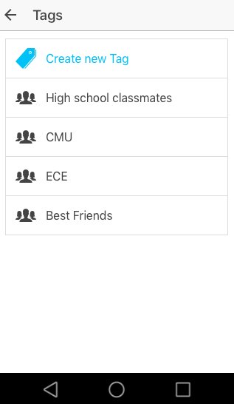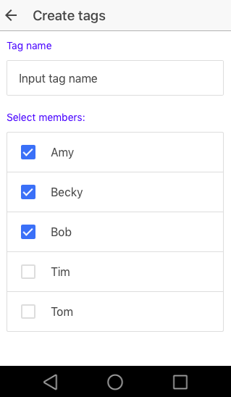

Figure 11

Users can classify their friends using tags. Like Figure 11, they can have as many tags as they like. Then users can post new games to some specific tags of friends. Also, one particular friend can have multiple tags.

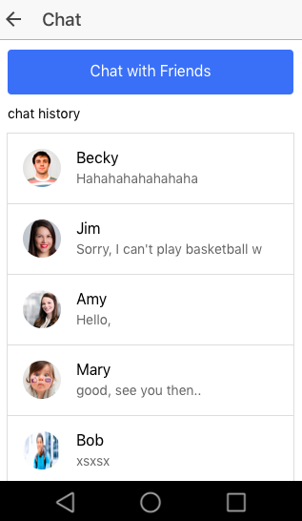 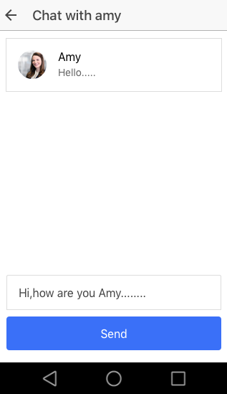

Figure12

We added the Chat functionality so that our user would not need to switch to some other application when they want to discuss about upcoming games. The "Chat " icon can show the chat history between users and their friends, and users can also choose one of their friends to start chatting. It's convenient for users to discuss games with their friends.

**Log out**

When users click log out button, users will go back to welcome page.

**Architecture**

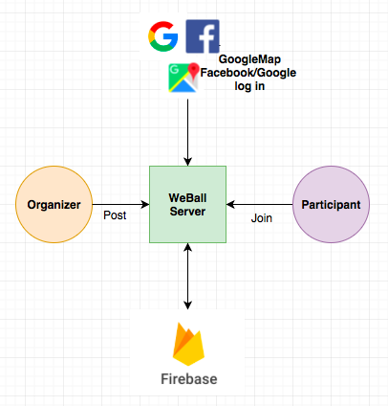

Our system mainly consists of two parts: the frontend Android phone manmaged by users and the JSON tree database on Firebase Realtime Database since now we have few users.

All user activities will be on the Android phone. Users would be able to post new games, search for games and view their profile on the phone.

Firebase is a two tier architecture, which means mobiles and firebase both can manipulate data directly. The Firebase Realtime Database allows nesting data up to 32 levels deep. When we fetch a data at a location in our database, we also retrieve all of its child nodes. And if we grant someone write or read access at a node in our database, we also grant them to access all data under that node. So, it's best to keep our data structure as flat as possible. As for WeBall, we store users' information like user name, email address, password, their posts under their special account ID. Each game will have their unique game id, which are randomly generated by database. When users join or delete a game, user ID and game ID will react according to the operation.

We are not expecting a lot of users right now. However, when the number of users gets large, keeping all the data would have a high cost. Thus, under this circumstance, our revenue model would need to be updated to charging users who have participated in more than ten games.The 3rd party APIs we are planning to use includes Google Maps Android API and Google Sign-In provided by Google and Facebook Sign-In from Facebook Android SDK provided by Facebook. With the Google Maps Android API, our users would be able to navigate themselves and select the target location of their post. With Google Sign-In and Facebook Sign-In integrated into our app, we enable our users to sign in with their Google and Facebook account.

**Privacy and Security**

**Privacy Policy**

1. What information we collect and how would we use this information?
   1. Information user provide to us
      1. Basic account information: In order to setup a WeBall account for a user, we require some basic account information, email address and password, from he/she. We would assign each user a user ID when their accounts get set up.
      2. Optional account information: The users may provide us with other information like phone number, phone contacts and social network data, but they are not required to do so. With phone number and phone contacts, WeBall could automatically detect those people in the contact list who also have WeBall accounts and have shared their phone number with us and users could then directly add them as their WeBall friends. WeBall also has the functionality that enables users to import their Facebook friends who also have WeBall accounts and have shared their social network data with us as their WeBall friends.
      3. Public profile information: We collect public profile information from our users to display on their profile page which would be public to all WeBall users. This kind of information includes profile picture, username. It is completely optional and it is users' responsibility to decide what information to provide to us. This kind of information enables users to know each other more before they decide to play a game together.
   2. Information we collect automatically
      1. Log information: We collect log information when users use WeBall. Log information that we collect includes IP address, unique device identifiers and data/time of access. We use this information to make analysis about usage trend and to provide better service to our users.
      2. Usage information (Queries run): We collect information of what actions users perform in our application. Namely, we record who did what at when. We collect this information to get an idea of how users use our application, to make analysis of the usage trends and to improve our application to make it more consistent with users' usage habits.
      3. Location information: We collect information about users' precise location via Google Maps API if users allow us to do so in their mobile device permission setting. The location information is necessary when users want to create a new game or to discover a new game.
2. How we share information?
   1. Information that shared publicly to all WeBall users: The information that users provide to us in their profile would be public to all WeBall users. The users themselves have the freedom to decide what to put in their profile.
   2. Information that shared to third party API: To use third party APIs, Facebook login and Google login, we would share users' email with them to enable the third party login functionality. When users choose to use third party login functionality, they consent with us sharing their email with the their party API.

Other than these two cases, we would not share users' information with others. We would not share, namely, give access of, the information that we collect from the users to the users themselves for security reasons.

1. Choices
   1. Users can limit what they provide to us: Users can decide whether to provide us with optional account information. However, if they do not provide us their phone number, phone contacts and social network data, importing friends from phone contacts and from Facebook would not be made available to them.
   2. Users can limit our access to their information on their phone: Mobile device operating systems provide users the ability to refuse to provide us certain information like location information. However, if users do not give us the location information, create games and discovers games would not be made available to them.
   3. Delete all their information from our system: Users have the option to delete all their information from our system. They can do so by deleting their accounts in the Me page.
2. How long we retain the information and how we dispose it?
   1. Information we retain ephemerally: We retain location information ephemerally because we expect users to change location constantly. We get users' location information only when users are making actions that need their location and we do not store it in our database. Thus, we do not need to dispose this information.
   2. Information we retain as long as the user has a WeBall account: Basic account information and optional account information. We dispose this information when users choose to delete their WeBall accounts by removing it from the Firebase database.
   3. Information we retain for up to 12 months: Log information including IP address, data/time of access, unique device identifiers and queries run. We dispose there kinds of information by removing them from the Firebase database.

**Security**

1. Data Accessibility

As we have said in the privacy policy, we share users' email addresses with Facebook and Google login APIs and we would only make the profile information public to WeBall users if our users agree to provide us with such information with the understanding that this information would be made public to other WeBall users. Other than that, all information would be strictly made inaccessible. Also, when users delete their WeBall accounts, we would remove all information related to that particular account from our database.

1. Enhanced Security Setting

We provide our users the option with enhanced security setting. Users can choose to enable it and use two-factor authentication to enhance the security of their account.

3. Parse server security

We use Firebase which using SSL with strong 2048 bit keys for their certificate. Firebase can manage the security of app using a full set of tools. Firebase provides authentication to identify users and to control access. It's also provides validation rules to help data validation.

**Conclusion and Future Development**

**Conclusion for mini3**

As now, here is what we have finished for mini3:

1. Design and Proposal

Our team has met and discussed about all the possibility and potentials of our App. And after the process of brainstorm, we wrote a detailed project proposal, and we also finished the overall design of our Apps’ workflow, functions and UI.

2. Survey and result analysis

After our deep discussion, we added much important questions and concerns in our survey and sent to other people. We analyzed the results and created WeBall’s basic functions according the users’ need.

3. App implementation

We also finished the major part of our App design on Ionic Creator. We have completed the basic features of our Apps.

**Future development**

1. Currently only users accepting the invite can add comments; but this feature will be made available to users rejecting posts in the next version of the prototype
2. Optional profile sharing to be included in future developments
3. People can invite friends from contacts on phone to our app.
4. Time period more than one hour can be split to slots of one hour to allow people join game in different time slot.

**Conclusion for mini4**

In the second half of the semester, we have finished:

1. According to the feedback and suggestions of several real users, we modified our user interface. We made it more realistic, practical and convenient for users to interact with other users.
2. As we mentioned in future development of mini3's report, we added the feature that users can add and invite friends from mobile contacts or Facebook.
3. After carefully reading and filling the PIA, we modified our privacy and security policy.
4. We implemented some feature of WeBall in Android Studio.

5. We added the feature that when the time period of a game more than one hour can be split to slots of one hour to allow people join game in different time slot.

Future Development

1. We need to modify our implementation in android studio.
2. We can invite more people to use WeBall and analyze the feedback to improve our design.

Implementation Documentation

In the second half of the semester, we implemented a lot of but not all features of our application in Android Studio.

1. Signup and Login features: We finished the signup and login features but we have not integrated with Facebook and Google Login APIs.
2. Create Games: We finished the create games feature and we can successfully push to our Firebase database. For this feature, we implemented the pop up date and time pickers and we integrated Google Map API although the map is currently static. So now users can create a new game by selecting game type, date, time and location.
3. Discover Games: We also finished the discover games feature. Users can now find available games by selecting game type, date, time and location.
4. Friends: We have built the friends structure.

**Appendix**

1. Code available in the Github repository for our project : <https://github.com/yizhuanj/weball.git>
2. Market sizing calculations for an initial release in Pittsburgh –

Student enrolment in US -

1. Grades 9 to 12 – 15M (~30% of 50M)
2. Additional private elementary and secondary – 5M (30% -> 150K)
3. Colleges and universities (attendance in Fall of ’17) – 20M

Student enrolment in Pittsburgh -

Population of Pittsburgh = 2.4M (city = 300K)

% conversion = 2.4M/325M ~ 0.74%

Targeting students in schools (elementary & primary), undergraduates, and graduates in Pittsburgh -

1. Grades 9 to 12 – 0.74% * 15M = 111K
2. Additional private elementary and secondary – 0.74% * 5M = 37K
3. Colleges and universities (attendance in Fall of ’17) – 0.74% * 20M = 148K

Number of students in Pittsburgh = 296K ~ 0.3M

Number of students who have played basketball in Pittsburgh = 0.3M*9% = 26,640

As of spring 2017, 30M people played basketball in US in last 12 months -> 9%

Total non-farm working population = 1.2M

Number of people who have played basketball in the last 12 months in Pittsburgh among the non-farm working population = 108K*0.74% ~ 800

Total people (students + working) who have played BB in the last 12 months in Pittsburgh = 27,440

Coverage of OTT (over-the-top) messaging apps in US -

Whatsapp – 16%

Messenger – 40%

Assuming 50% use above + another 20% (others – WeChat/GroupMe/Line) -> 70% coverage

So, maximum number of people who can be offered WeBall and who likely do not use any competing app = 30% * 27,440 = 8,232